CT UNIVERSITY

PRACTICAL FILE


SECURITY INTELLIGENEC LAB
(24BCCS24E02)

Submitted by :
Name:Anmoldeep SinghSidhu
Submitted to:Mr. Nikhil Pandey
Program : BCA (CS) IBM Faculty
Sem. : 4^{th –} C SOET
Reg. No. 72413888

Index

SR  No | Practical | Page No
1. | Wazuh Installation and Architecture Setup
2. | Wazuh Agent Deployment and Registration
3. | Log Collection and Analysis
4. | File Integrity Monitoring (FIM)
5. | Security Configuration Assessment (SCA)
6. | Threat Detection Using Rules and Decoder
7. | Vulnerability Detection and Assessment
8. | Active Response Configuration
9. | Malware Detection and Rootkit Checks
10. | Dashboard Visualization and Reporting

INSTALLING THE WAZUH MAIN COMPONENTS
Download and run the Wazuh installation assistant.
curl -sO https://packages.wazuh.com/4.10/wazuh-install.sh && sudo bash ./wazuh-install.sh -a
Once the assistant finishes the installation, the output shows the access credentials and a message that confirms that the installation was successful.

INFO: --- Summary ---
INFO: You can access the web interface https://<WAZUH_DASHBOARD_IP_ADDRESS> User: admin
Password: <ADMIN_PASSWORD> INFO: Installation finished.
You now have installed and configured Wazuh.

Access the Wazuh web interface with https://<WAZUH_DASHBOARD_IP_ADDRESS> and your credentials:

Username: admin

Password: <ADMIN_PASSWORD>

When you access the Wazuh dashboard for the first time, the browser shows a warning message stating that the certificate was not issued by a trusted authority. This is expected and the user has the option to accept the certificate as an exception or, alternatively, configure the system to use a certificate from a trusted authority.
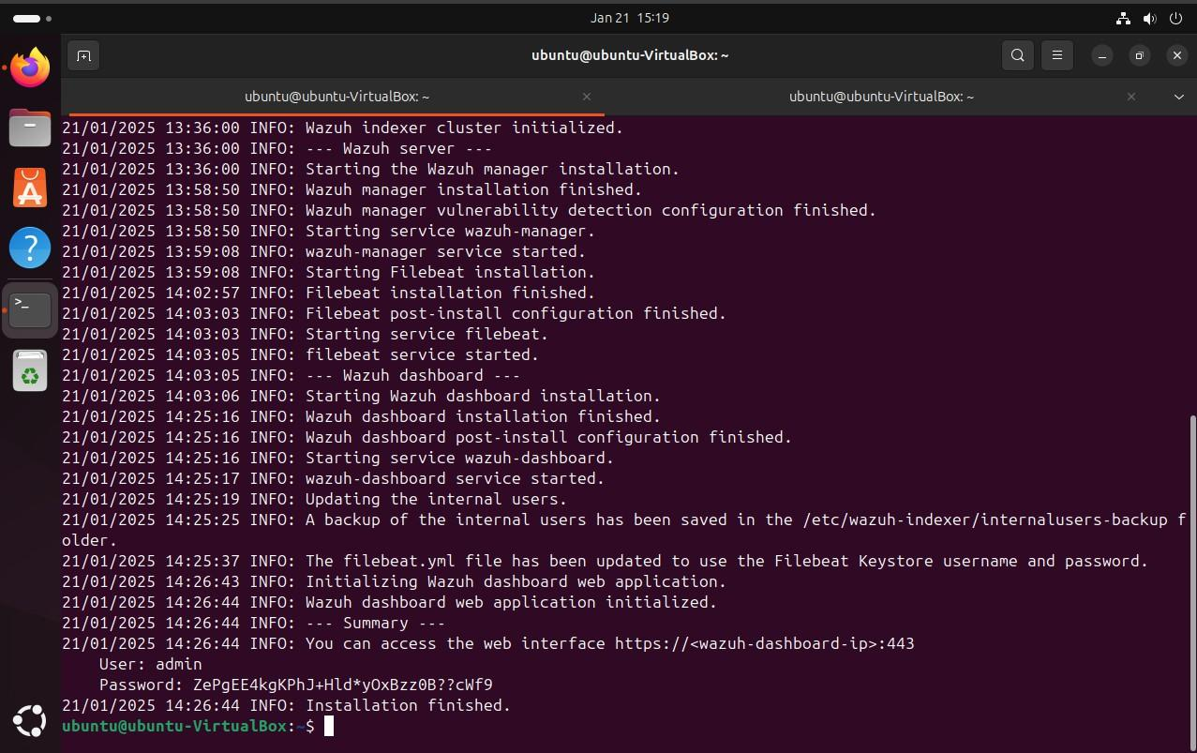

BLOCKING A KNOWN MALICIOUS ACTOR IN YOUR ENVIRONMENT

Install Apache Web Server:

  - Install the latest Visual C++ Redistributable package.

  - Download Apache Win64 ZIP binary.

  - Extract the contents and move the Apache24 folder to C:\.

Open PowerShell as Administrator and run:

cd C:\Apache24\bin
.\httpd.exe

  - Allow access when prompted by Windows Defender.

  - Verify access via http://<WINDOWS_IP>.
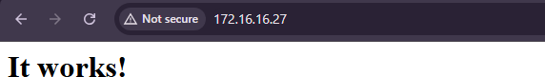

Configure Wazuh Agent:

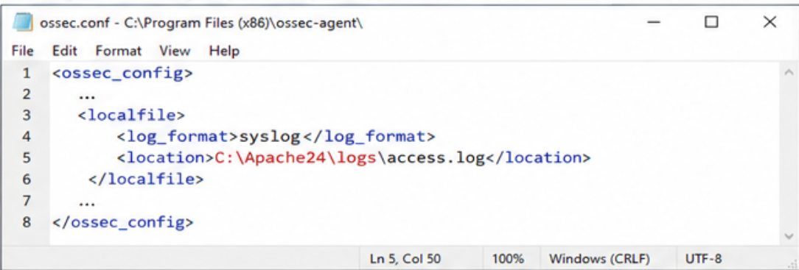

Edit C:\Program Files (x86)\ossec-agent\ossec.conf and add:

<localfile>
<log_format>syslog</log_format>
<location>C:\Apache24\logs\access.log</location>
</localfile>

Restart the Wazuh agent with: Restart-Service -Name wazuh
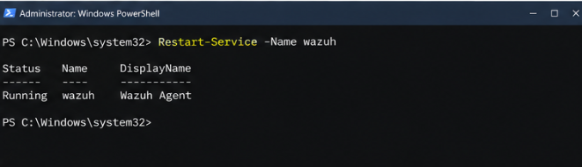

Ubuntu (Wazuh Server Configuration)

- Download IP Reputation Database and Convert It:

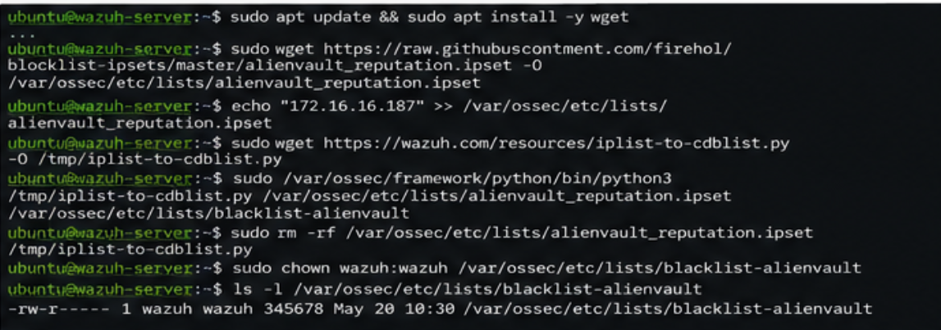
Install dependencies and download the database:

sudo apt update && sudo apt install -y wget sudo wget
https://raw.githubusercontent.com/firehol/blocklist-ipsets/master/alienvault_reputation.ipset -O
/var/ossec/etc/lists/alienvault_reputation.ipset
Append the attacker IP (Kali):
echo "172.16.16.187" >> /var/ossec/etc/lists/alienvault_reputation.ipset

Convert it to .cdb format:

sudo wget https://wazuh.com/resources/iplist-to-cdblist.py -O /tmp/iplist-to-cdblist.py sudo /var/ossec/framework/python/bin/python3 /tmp/iplist-to-cdblist.py
/var/ossec/etc/lists/alienvault_reputation.ipset /var/ossec/etc/lists/blacklist-alienvault

Clean up files:

sudo rm -rf /var/ossec/etc/lists/alienvault_reputation.ipset /tmp/iplist-to-cdblist.py

Set permissions:

sudo chown wazuh:wazuh /var/ossec/etc/lists/blacklist-alienvault

- Add Custom Rule in Wazuh:
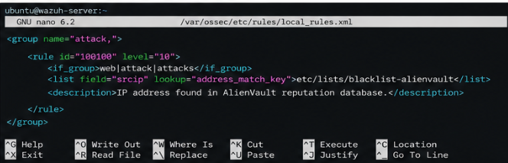

Edit /var/ossec/etc/rules/local_rules.xml and add:

<group name="attack,">
<rule id="100100" level="10">
<if_group>web|attack|attacks</if_group>
<list field="srcip" lookup="address_match_key">etc/lists/blacklist-alienvault</list>
<description>IP address found in AlienVault reputation database.</description>
</rule>
</group>

- Configure Wazuh Ruleset:
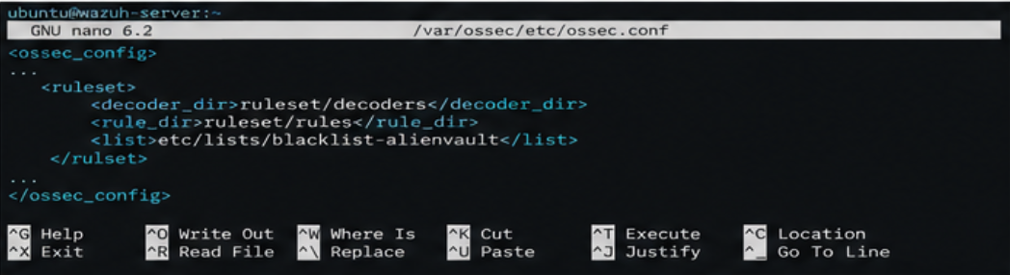

Edit /var/ossec/etc/ossec.conf and add under <ruleset>:

<list>etc/lists/blacklist-alienvault</list>

- Configure Active Response Module:
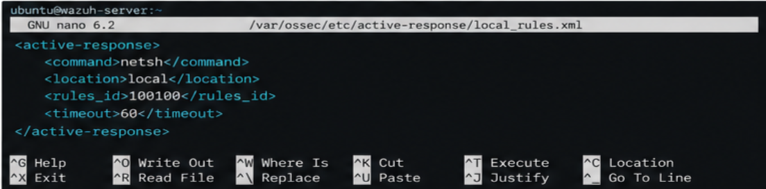

For Windows (netsh firewall block):

<active-response>
<command>netsh</command>
<location>local</location>
<rules_id>100100</rules_id>
<timeout>60</timeout>
</active-response>

Restart Wazuh Manager:
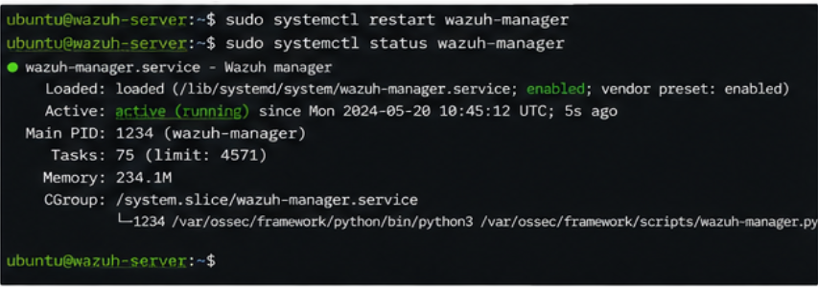

sudo systemctl restart wazuh-manager

Attack Emulation
On your Kali Linux attacker machine, try accessing the Windows Apache web server: curl http://<WINDOWS_IP>
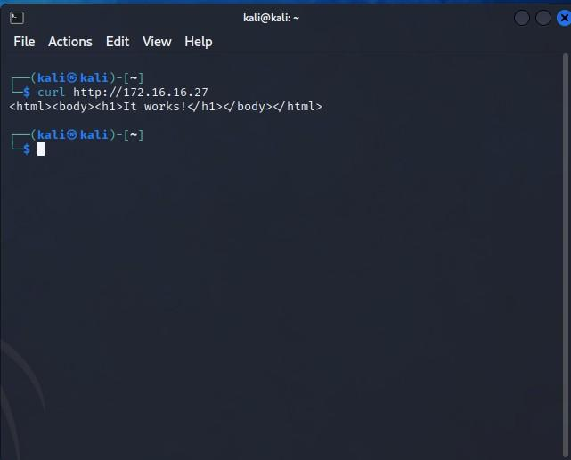

After the first attempt, Wazuh should block further access for 60 seconds.

Visualizing Alerts
- Go to the Wazuh dashboard.
- Navigate to Threat Hunting and filter for alerts related to the attack.
- Confirm that the Kali IP (172.16.16.187) is being blocked.

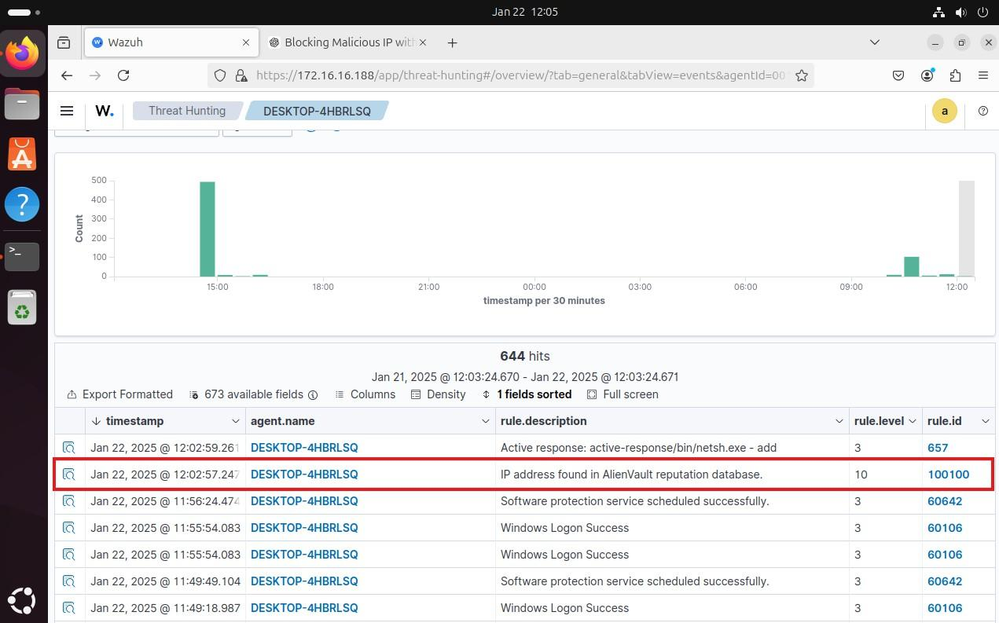

INTEGRITY MONITORING (FIM) FOR YOUR WAZUH POC
Infrastructure Overview

  - Ubuntu Server (Wazuh Agent Installed): Monitor the /root directory.
  - Windows 11 Endpoint (Wazuh Agent Installed): Monitor the
C:\Users\Administrator\Desktop directory.

Ubuntu Endpoint Configuration (Wazuh Agent on Ubuntu Server)
Edit the Wazuh agent configuration file:
Open the agent configuration file on your Ubuntu server:

sudo nano /var/ossec/etc/ossec.conf
Add the following within the <syscheck> block to monitor the /root directory:

<syscheck>
<directories check_all="yes" report_changes="yes" realtime="yes">/root</directories>
</syscheck>

1. Save and exit the file (CTRL+X, Y, Enter).

Restart the Wazuh agent to apply the changes:

sudo systemctl restart wazuh-agent

Windows 11 Endpoint Configuration
Edit the Wazuh agent configuration file:
Open the following file in Notepad (with Administrator privileges):

C:\Program Files (x86)\ossec-agent\ossec.conf
Add the following within the <syscheck> block to monitor the desktop directory:

<syscheck>
<directories check_all="yes" report_changes="yes" realtime="yes">C:\Users\Administrator\Desktop</directories>
</syscheck>

- Save the file and close Notepad.

Restart the Wazuh agent using PowerShell as Administrator:

Restart-Service -Name wazuh

Centralized Configuration (Optional)
Instead of configuring each agent locally, you can configure file monitoring centrally via the Wazuh server:
On the Wazuh manager, edit the agent configuration template:

sudo nano /var/ossec/etc/shared/default/agent.conf Add the following within the <syscheck> block:

<syscheck>
<directories check_all="yes" report_changes="yes" realtime="yes">/root</directories>
<directories check_all="yes" report_changes="yes" realtime="yes">C:\Users\Administrator\Desktop</directories>
</syscheck>
Save and restart the Wazuh manager:

sudo systemctl restart wazuh-manager

Testing the Configuration
- Ubuntu Test:

Create a test file:
sudo touch /root/testfile.txt

Modify the file:
echo "Testing FIM" | sudo tee -a /root/testfile.txt

Delete the file:
sudo rm /root/testfile.txt

- Windows Test:

  - Create a text file on the desktop.
  - Edit the file and save it.
  - Delete the file.
- Wait for 5-10 seconds for alerts to generate.

Viewing Alerts in the Wazuh Dashboard
- Login to your Wazuh Dashboard.

- Navigate to "Security events" > "File Integrity Monitoring."

- Use the following search queries to filter results:

Ubuntu Endpoint:
rule.groups: "ossec,syscheck" AND data.file.path: "/root"

Windows Endpoint:
rule.groups: "ossec,syscheck" AND data.file.path: "C:\\Users\\Administrator\\Desktop"

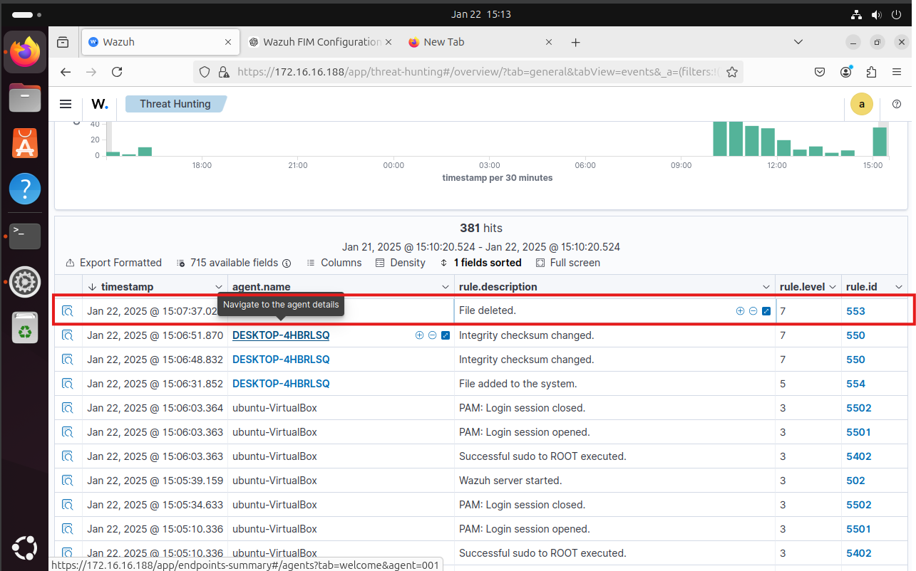

DETECTING A BRUTE-FORCE ATTACK

Configuration Steps
- Prepare the Attacker Endpoint (Kali Linux) Update package lists and install Hydra:
sudo apt update
sudo apt install -y hydra

Create a password list with 10 random passwords:

echo -e
"password1\npassword2\n123456\nadmin\ntest\nqwerty\nletmein\nwelcome\nmonkey\npasswor d123" > passwd_list.txt

SSH Brute-Force Attack on Ubuntu Server
Run the following command to simulate an SSH brute-force attack on the Ubuntu server: sudo hydra -l badguy -P passwd_list.txt 10.0.2.5 ssh
  - Replace 10.0.2.5 with your Ubuntu server's IP.

RDP Brute-Force Attack on Windows 11
Run the following command to simulate an RDP brute-force attack on the Windows 11 endpoint: sudo hydra -l badguy -P passwd_list.txt rdp://<WINDOWS_IP>
  - Replace <WINDOWS_IP> with the IP address of your Windows 11 machine.
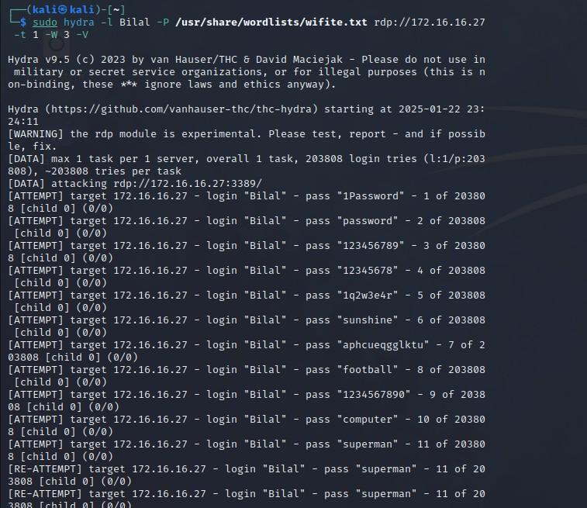

Wazuh Configuration for Detection
Your Wazuh server should already have rules in place to detect brute-force attacks. However, ensure the SSH and RDP logs are being collected.

Ubuntu (SSH) Configuration:

Open the Wazuh agent configuration file:

sudo nano /var/ossec/etc/ossec.conf

Ensure the following SSH log collection block is present:

<localfile>
<location>/var/log/auth.log</location>
<log_format>syslog</log_format>
</localfile>

Restart the Wazuh agent:

sudo systemctl restart wazuh-agent

Windows (RDP) Configuration:
In the Windows agent's ossec.conf, ensure event log monitoring for RDP is enabled:

<localfile>
<location>Security</location>
<log_format>eventchannel</log_format>
</localfile>

Restart the Wazuh agent via PowerShell:
Restart-Service -Name wazuh

Visualizing Alerts in Wazuh Dashboard
To monitor the brute-force attack events:

- Login to your Wazuh dashboard.
- Navigate to "Threat Hunting" > "Security events."
Use the following search query for Linux (Ubuntu) brute-force attempts:

rule.id:(5551 OR 5712 OR 5710 OR 5711 OR 5716 OR 5720 OR 5503 OR 5504) AND
data.win.system.eventID: "4625"

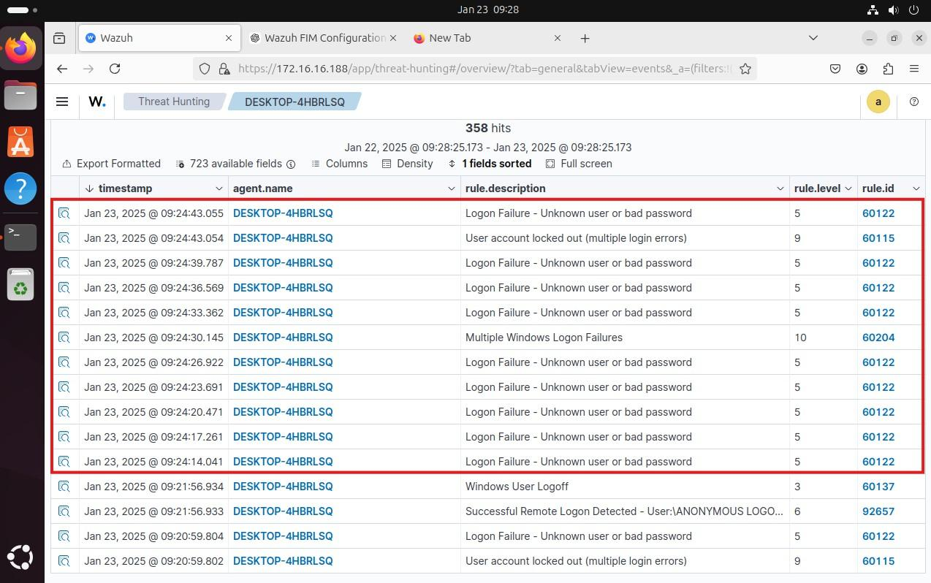
Use the following search query for Windows (RDP) brute-force attempts: rule.id: "18107" OR rule.description: "Multiple Windows logon failures"

MONITORING DOCKER EVENTS

Steps to Enable Docker Monitoring on the Wazuh Manager (Ubuntu):
Install Python and pip:

sudo apt install python3 python3-pip -y

Upgrade pip to the latest version:

pip3 install --upgrade pip

Install Docker and required Python libraries:

curl -sSL https://get.docker.com/ | sh
sudo pip3 install docker==7.1.0 urllib3==1.26.20 requests==2.32.2

Edit the Wazuh configuration file to enable Docker monitoring:
Open /var/ossec/etc/ossec.conf and add the following block inside <ossec_config>:

<wodle name="docker-listener">
<interval>10m</interval>
<attempts>5</attempts>
<run_on_start>yes</run_on_start>
<disabled>no</disabled>
</wodle>

Fix potential Python-related errors: If you encounter errors like ‘python’: No such file or directory, create a symbolic link:

sudo ln -s /usr/bin/python3 /usr/bin/python
Restart the Wazuh manager to apply changes:

sudo systemctl restart wazuh-manager

Testing the Setup:
Perform some Docker actions to generate logs:

sudo docker pull nginx
sudo docker run -d -P --name nginx_container nginx sudo docker exec -it nginx_container cat /etc/passwd sudo docker exec -it nginx_container /bin/bash
exit
sudo docker stop nginx_container sudo docker rm nginx_container

Viewing Alerts in the Wazuh Dashboard:
- Log into the Wazuh dashboard.
- Navigate to Modules > Docker to view container-related events.
- Check for alerts related to Docker actions such as container creation, deletion, and execution.
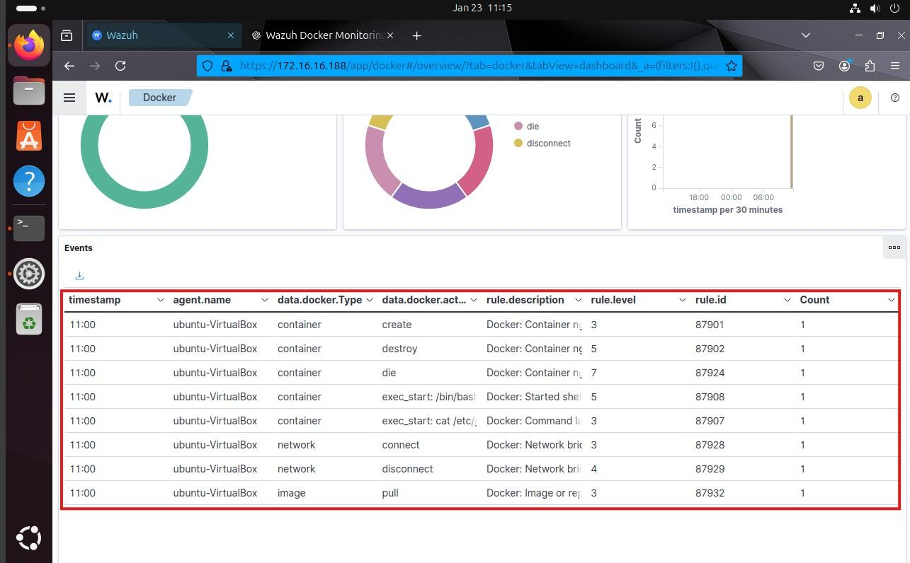

DETECTING UNAUTHORIZED PROCESSES

Steps to Detect Unauthorized Processes (Netcat) on Windows

Windows Agent Configuration (Modify ossec.conf)

On your Windows Wazuh agent, follow these steps to configure command monitoring: Open the Wazuh agent configuration file located at:
C:\Program Files (x86)\ossec-agent\ossec.conf

Add the following configuration block to periodically get a list of running processes:

<ossec_config>
<localfile>
<log_format>full_command</log_format>
<alias>process list</alias>
<command>tasklist /FO CSV</command>
<frequency>30</frequency>
</localfile>
</ossec_config>

Restart the Wazuh agent to apply changes by running the following in an elevated Command Prompt:

net stop wazuh net start wazuh

Install Netcat on Windows for Testing

- Download Netcat for Windows from a trusted source (e.g., Nmap's official website).

- Extract and place nc.exe in a known location (e.g., C:\tools\nc.exe).
To simulate an attack, run the following in PowerShell: nc.exe -l -p 8000

Ubuntu Wazuh Manager Configuration (Modify Rules)

On your Ubuntu Wazuh manager, create a rule to detect the presence of Netcat in the process list.
Edit the local rules file on the Wazuh manager:

sudo nano /var/ossec/etc/rules/local_rules.xml Add the following rule to detect Netcat running:

<group name="ossec,">
<rule id="100050" level="0">
<if_sid>530</if_sid>
<match>^ossec: output: 'process list'</match>
<description>List of running processes.</description>
<group>process_monitor,</group>
</rule>
<rule id="100051" level="7" ignore="900">
<if_sid>100050</if_sid>
<match>nc.exe</match>
<description>Netcat detected running on Windows.</description>
<group>process_monitor,</group>
</rule>
</group>

- Save and exit the file (Ctrl+X, Y, Enter).
Restart the Wazuh manager to apply the changes: sudo systemctl restart wazuh-manager

Attack Emulation on Windows

To test detection, run the following command on your Windows endpoint: nc.exe -l -p 8000

Let it run for 30 seconds, then stop it.

Visualize Alerts in Wazuh Dashboard
- Log in to the Wazuh dashboard.

- Navigate to Threat Hunting module.

In the search bar, enter the following query to find alerts related to Netcat: rule.id:(100051)
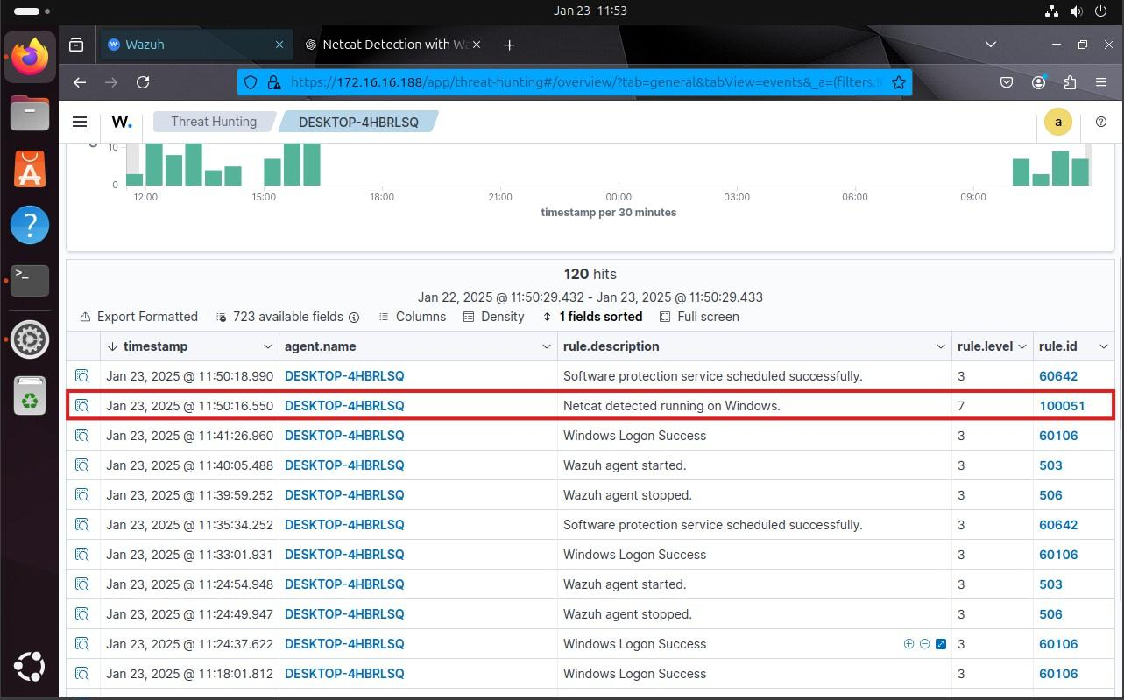

DETECTING AN SQL INJECTION ATTACK

Configure the Ubuntu Wazuh Manager (Web Server)

Install and Configure Apache:
sudo apt update
sudo apt install apache2

Configure Firewall (if applicable):
sudo ufw allow 'Apache' sudo ufw status

Verify Apache Installation:
sudo systemctl status apache2 curl http://<UBUNTU_IP>

Add Apache Log Monitoring to Wazuh Agent Configuration:

Edit the Wazuh agent configuration on your Windows machine (Wazuh agent): Open the Wazuh agent configuration file on Windows:
C:\Program Files (x86)\ossec-agent\ossec.conf

Add the following configuration to monitor Apache logs (if logs are collected remotely or via file sharing):

<localfile>
<log_format>apache</log_format>
<location>C:\path\to\apache\logs\access.log</location>
</localfile>
Restart the Wazuh agent service on Windows:

Restart-Service wazuh

Alternatively, if you want to monitor logs directly on the Ubuntu server, modify
/var/ossec/etc/ossec.conf with:
<ossec_config>
<localfile>
<log_format>apache</log_format>
<location>/var/log/apache2/access.log</location>
</localfile>
</ossec_config>

Restart the agent on Ubuntu:

sudo systemctl restart wazuh-agent

Simulate SQL Injection Attack from Kali Linux (Attacker)
Run the following command from your Kali Linux machine to simulate an attack: curl -XGET "http://<UBUNTU_IP>/users/?id=SELECT+*+FROM+users";

Verify the Detection in Wazuh Dashboard

  - Access the Wazuh dashboard via https://<WAZUH_MANAGER_IP>:5601

  - Navigate to "Threat Hunting" module.

Use the following query to filter SQL injection alerts:

rule.id:31103
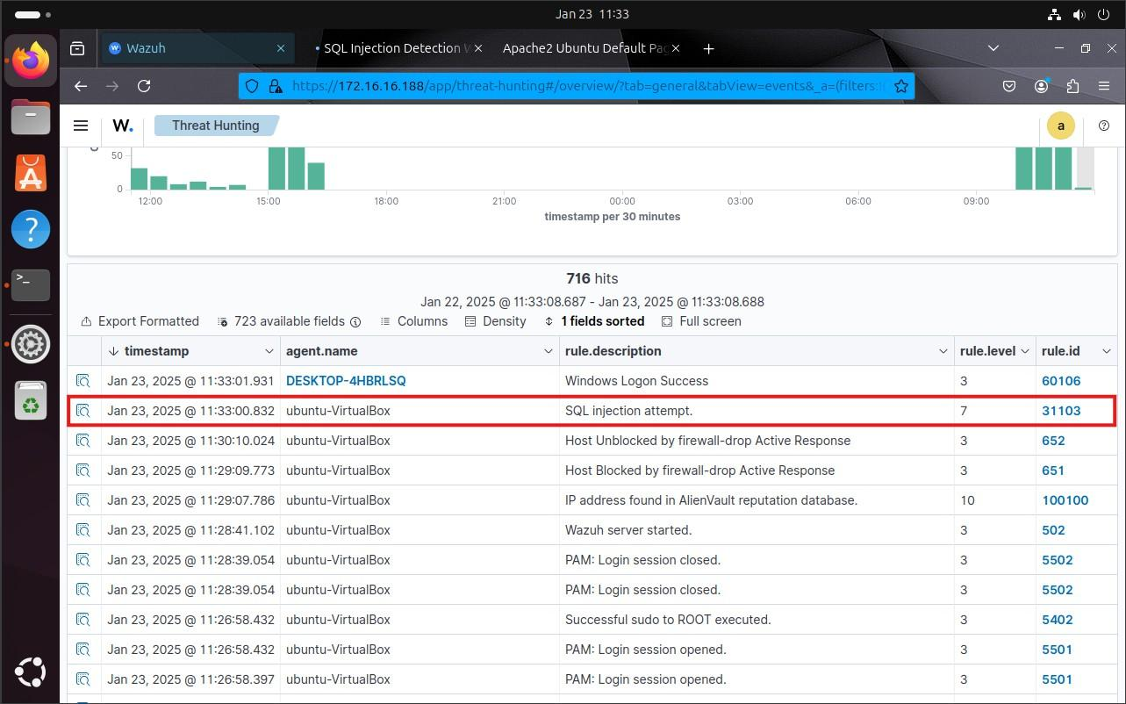

7.DETECTING AND REMOVING MALWARE USING VIRUSTOTAL INTEGRATION

Configure VirusTotal integration: In /var/ossec/etc/ossec.conf, add the integration block:

<ossec_config>
<integration>
<name>virustotal</name>
<api_key><YOUR_VIRUS_TOTAL_API_KEY></api_key>
<rule_id>100200,100201</rule_id>
<alert_format>json</alert_format>
</integration>
</ossec_config>
Enable active response:

<ossec_config>
<command>
<name>remove-threat</name>
<executable>remove-threat.sh</executable>
<timeout_allowed>no</timeout_allowed>
</command>
<active-response>
<disabled>no</disabled>
<command>remove-threat</command>
<location>local</location>
<rules_id>87105</rules_id>
</active-response>
</ossec_config>

Restart Wazuh manager:

sudo systemctl restart wazuh-manager

Windows Agent Configuration
Enable FIM monitoring on the Windows agent: In C:\Program Files
(x86)\ossec-agent\ossec.conf, ensure <disabled> is set to "no" and configure the directory:

<directories realtime="yes">C:\Users\<USER_NAME>\Downloads</directories>

Install Python and PyInstaller: Install Python and PyInstaller on your Windows agent: pip install pyinstaller
pyinstaller --version

- Create the active response Python script: Create remove-threat.py with the provided Python script content.:
#!/bin/bash LOCAL=`dirname $0`; cd $LOCAL
cd ../ PWD=`pwd`
read INPUT_JSON
FILENAME=$(echo $INPUT_JSON | jq -r .parameters.alert.data.virustotal.source.file) COMMAND=$(echo $INPUT_JSON | jq -r .command) LOG_FILE="${PWD}/../logs/active-responses.log"
if [ ${COMMAND} = "add" ]; then printf
'{"version":1,"origin":{"name":"remove-threat","module":"active-response"},"command":"check_k eys", "parameters":{"keys":[]}}\n'
read RESPONSE
COMMAND2=$(echo $RESPONSE | jq -r .command) if [ ${COMMAND2} != "continue" ]; then
echo "`date '+%Y/%m/%d %H:%M:%S'` $0: $INPUT_JSON Remove threat active response aborted" >> ${LOG_FILE}
exit 0;
fi
fi
rm -f $FILENAME if [ $? -eq 0 ]; then
echo "`date '+%Y/%m/%d %H:%M:%S'` $0: $INPUT_JSON Successfully removed threat" >>
${LOG_FILE}
else
echo "`date '+%Y/%m/%d %H:%M:%S'` $0: $INPUT_JSON Error removing threat" >>
${LOG_FILE}
fi
exit 0;

Convert Python script to executable: Use PyInstaller to convert the script into a Windows executable:

pyinstaller -F \path_to_remove-threat.py

- Move the executable to the active-response directory: Move remove-threat.exe
to C:\Program Files (x86)\ossec-agent\active-response\bin.

Restart the Wazuh agent:

Restart-Service -Name wazuh
Configure VirusTotal integration on the Wazuh server: On the Wazuh server, add the VirusTotal integration configuration:

<ossec_config>
<integration>
<name>virustotal</name>
<api_key><YOUR_VIRUS_TOTAL_API_KEY></api_key>
<group>syscheck</group>
<alert_format>json</alert_format>
</integration>
</ossec_config>

Enable active response on the Wazuh server:

<ossec_config>
<command>
<name>remove-threat</name>
<executable>remove-threat.exe</executable>
<timeout_allowed>no</timeout_allowed>
</command>
<active-response>
<disabled>no</disabled>
<command>remove-threat</command>
<location>local</location>
<rules_id>87105</rules_id>
</active-response>
</ossec_config>

Restart the Wazuh manager:

sudo systemctl restart wazuh-manager

For the Windows endpoint, download the EICAR test file:

Invoke-WebRequest -Uri https://secure.eicar.org/eicar.com.txt -OutFile eicar.txt cp .\eicar.txt C:\Users\<USER_NAME>\Downloads

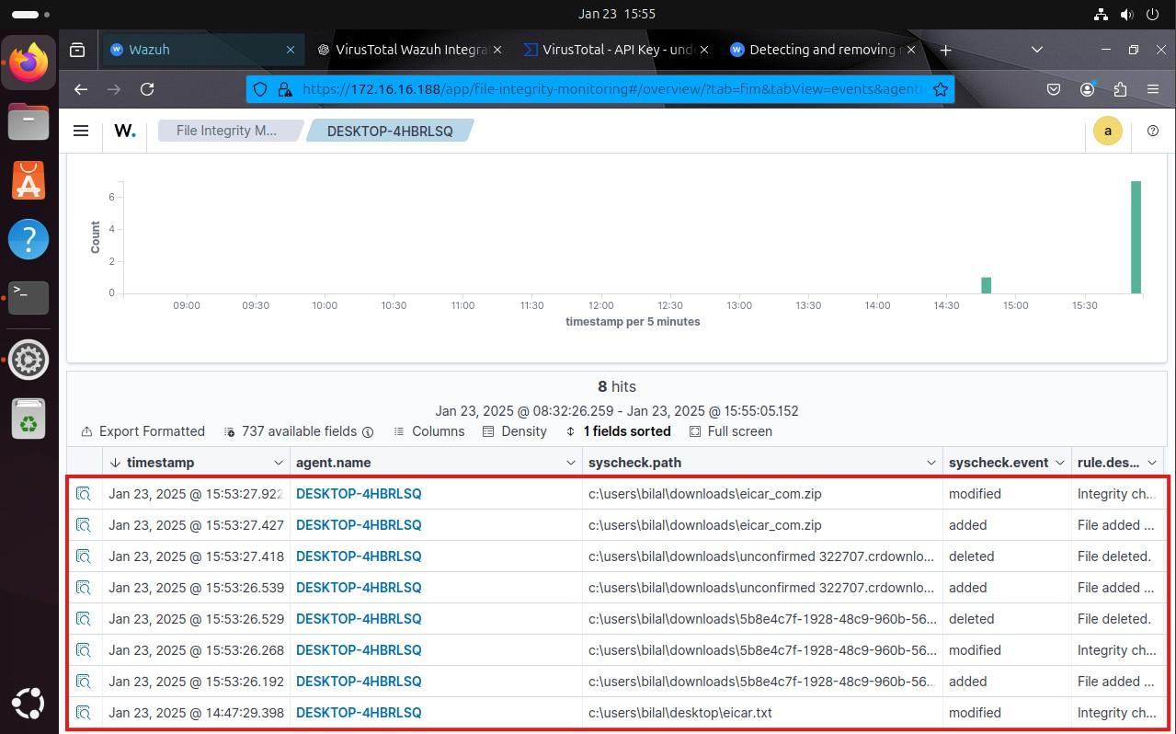

VULNERABILITY DETECTION WITH WAZUH

Configuration Steps

Enabling the Vulnerability Detection Module

Ensure that the vulnerability detection module is enabled on the Wazuh manager: Open the Wazuh configuration file:
sudo nano /var/ossec/etc/ossec.conf

Verify or configure the <vulnerability-detection> section:

<vulnerability-detection>
<enabled>yes</enabled>
<index-status>yes</index-status>
<feed-update-interval>60m</feed-update-interval>
</vulnerability-detection>
Ensure the <indexer> section points to the correct Wazuh indexer node:
<indexer>
<enabled>yes</enabled>
<hosts>
<host>https://<wazuh_manager_ip>:9200</host>
</hosts>
<ssl>
<certificate_authorities>
<ca>/etc/filebeat/certs/root-ca.pem</ca>
</certificate_authorities>
<certificate>/etc/filebeat/certs/filebeat.pem</certificate>
<key>/etc/filebeat/certs/filebeat-key.pem</key>
</ssl>
</indexer>

Restart the Wazuh manager:
sudo systemctl restart wazuh-manager

Agent Configuration for Vulnerability Detection

On the Windows 11 agent:

  - Verify the Wazuh agent is installed and running.
  - Ensure Syscollector is enabled in the ossec.conf file:
    - File location: C:\Program Files (x86)\ossec-agent\ossec.conf

<wodle name="syscollector">
<disabled>no</disabled>
<interval>3600</interval>
<scan_on_start>yes</scan_on_start>
<hardware>yes</hardware>
<os>yes</os>
<packages>yes</packages>
<ports all="yes">yes</ports>
<processes>yes</processes>
</wodle>

Restart the agent service: Restart-Service wazuh

Testing and Visualization

Detecting the Vulnerability

  - Install an outdated version of Docker Desktop (e.g., 4.28.0).
  - Wait for Syscollector to scan and update inventory data.

Viewing Vulnerabilities in the Dashboard

  - Go to Vulnerability Detection > Inventory.

Use the following query to filter for Docker Desktop vulnerabilities: package.name:docker-desktop
To view vulnerability alerts, switch to Events and filter using: data.vulnerability.package.name: docker-desktop AND data.vulnerability.status:Active

Resolving the Vulnerability
- Update Docker Desktop to version 4.34.2 or later.
  - Download the latest version from the Docker Desktop website.
- Wait for Syscollector to scan and update the package status.
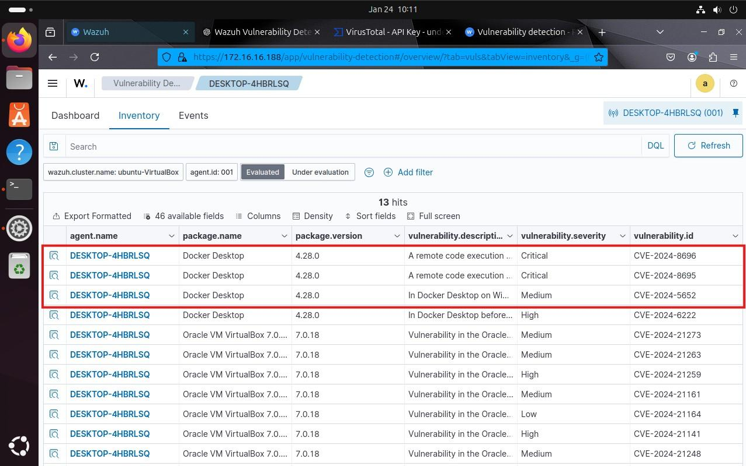

DETECTING HIDDEN PROCESSES

Configure the Ubuntu Endpoint

Switch to root and update the system:
sudo su apt update

Install necessary packages:
apt -y install gcc git

Configure Wazuh agent for frequent rootcheck scans:

Edit the agent configuration file /var/ossec/etc/ossec.conf and update the
<rootcheck> section:

<rootcheck>
<disabled>no</disabled>
<check_files>yes</check_files>
<check_trojans>yes</check_trojans>
<check_dev>yes</check_dev>
<check_sys>yes</check_sys>
<check_pids>yes</check_pids>
<check_ports>yes</check_ports>
<check_if>yes</check_if>

<!-- rootcheck execution frequency - every 2 minutes -->
<frequency>120</frequency>

<rootkit_files>etc/shared/rootkit_files.txt</rootkit_files>
<rootkit_trojans>etc/shared/rootkit_trojans.txt</rootkit_trojans>
<skip_nfs>yes</skip_nfs>
</rootcheck>

Restart the Wazuh agent to apply changes:
systemctl restart wazuh-agent

Deploy the Diamorphine Rootkit (Attack Emulation)

Clone the rootkit repository:
git clone https://github.com/m0nad/Diamorphine

Compile the rootkit:
cd Diamorphine make

Load the rootkit kernel module:
insmod diamorphine.ko

If the module fails to load, restart the endpoint and try again.

Verify if the rootkit is hidden:
lsmod | grep diamorphine

Expected output: Empty.

Unhide the rootkit (for testing):
kill -63 <PID>
lsmod | grep diamorphine

Expected output: diamorphine 13155 0

Hide a running process (e.g., rsyslogd):
ps auxw | grep rsyslogd | grep -v grep

Find the PID of rsyslogd and run: kill -31 <PID>
ps auxw | grep rsyslogd | grep -v grep

Expected output: Empty.

Verify Detection in Wazuh Dashboard
Once the Wazuh agent runs the rootcheck scan, alerts should be generated. To visualize them:

  - Log in to the Wazuh dashboard.
  - Navigate to Threat Hunting.

Use the filter:
rule.groups:rootcheck

  - Look for alerts related to hidden processes.
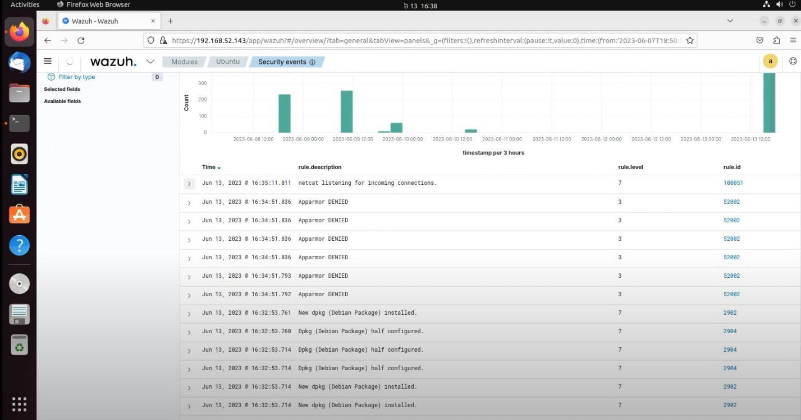

MONITORING EXECUTION OF MALICIOUS COMMANDS

Ubuntu Endpoint Configuration
Install and configure Auditd on your Ubuntu endpoint to monitor command executions:

sudo apt -y install auditd sudo systemctl start auditd sudo systemctl enable auditd

Append the following rules to /etc/audit/audit.rules:
echo "-a exit,always -F auid=1000 -F egid!=994 -F auid!=-1 -F arch=b32 -S execve -k audit-wazuh-c" >> /etc/audit/audit.rules
echo "-a exit,always -F auid=1000 -F egid!=994 -F auid!=-1 -F arch=b64 -S execve -k audit-wazuh-c" >> /etc/audit/audit.rules

Reload the audit rules and confirm they are active:

sudo auditctl -R /etc/audit/audit.rules sudo auditctl -l

Add the following configuration in your Wazuh agent's ossec.conf to monitor the Auditd logs:

<localfile>
<log_format>audit</log_format>
<location>/var/log/audit/audit.log</location>
</localfile>
Restart the Wazuh agent:

sudo systemctl restart wazuh-agent

Wazuh Server Configuration
Create a CDB list (/var/ossec/etc/lists/suspicious-programs) with suspicious commands:

ncat:yellow nc:red Tcpdump:orange

Add the list in the <ruleset> section of your Wazuh server’s ossec.conf:

<list>etc/lists/suspicious-programs</list>

Create a custom rule in the local_rules.xml file to detect execution of "red" programs:

<group name="audit">
<rule id="100210" level="12">
<if_sid>80792</if_sid>
<list field="audit.command" lookup="match_key_value" check_value="red">etc/lists/suspicious-programs</list>
<description>Audit: Highly Suspicious Command executed: $(audit.exe)</description>
<group>audit_command,</group>
</rule>
</group>
Restart the Wazuh manager:

sudo systemctl restart wazuh-manager

Attack Emulation
On the Ubuntu endpoint, install and run a "red" program like netcat: sudo apt -y install netcat
nc -v

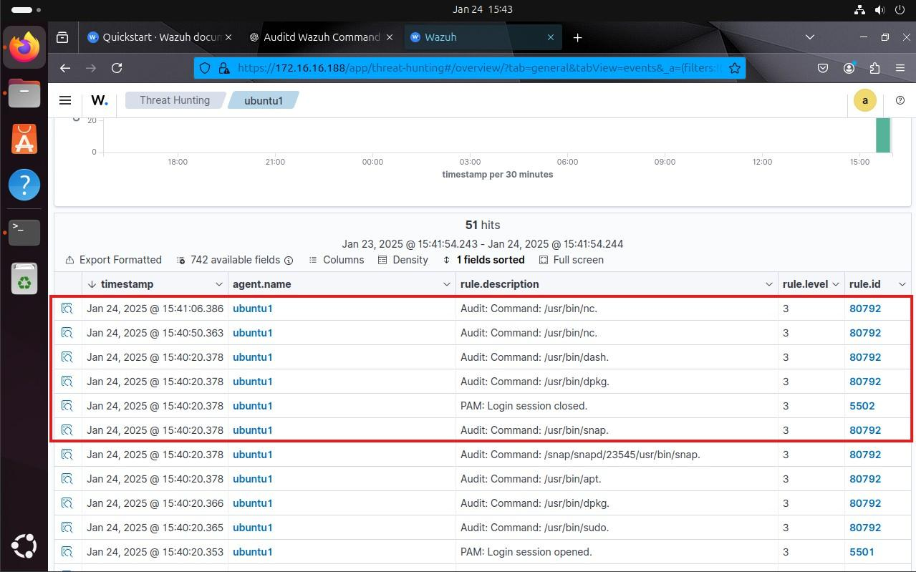

DETECTING A SHELLSHOCK ATTACK

Ubuntu Wazuh Agent (Victim) - Setup
Install Apache web server:

sudo apt update
sudo apt install apache2 -y

Configure firewall (if enabled):

sudo ufw app list
sudo ufw allow 'Apache' sudo ufw status

Verify Apache is running:

sudo systemctl status apache2

Configure Wazuh agent to monitor Apache logs: Edit the agent configuration file
/var/ossec/etc/ossec.conf and add:

<localfile>
<log_format>syslog</log_format>
<location>/var/log/apache2/access.log</location>
</localfile>

Restart the Wazuh agent:

sudo systemctl restart wazuh-agent

Kali Linux (Attacker) - Attack Simulation

Replace <WEBSERVER_IP_ADDRESS> with the IP address of your Ubuntu Wazuh agent and execute:
sudo curl -H "User-Agent: () { :; }; /bin/cat /etc/passwd" http://<WEBSERVER_IP_ADDRESS>

Viewing Alerts in Wazuh Dashboard
  - Open the Wazuh dashboard.
  - Navigate to Threat Hunting module.

Use the following query to find Shellshock-related alerts: rule.description:Shellshock attack detected

Index

SR  No | Practical | Page No
1. | Splunk Installation and Setup
2. | Using Data Encryption techniques for securing data at rest
3. | Detection of Simulated Brute Force Attacks
4. | Web Application Log Analysis
5. | Network Scanning and Attack Traffic Analysis
6. | Alert Creation and Security Dashboards
7. | Incident Reporting and Audit Documentation
8. | Detection of Passwords in Plain Text Traffic

Practical No.
(Splunk)
Install Splunk Enterprise in a controlled lab environment. Configure users, roles, data inputs, and indexes. Understand Splunk architecture components such as forwarders, indexers, and search heads, and verify successful data ingestion.

Installation of splunk

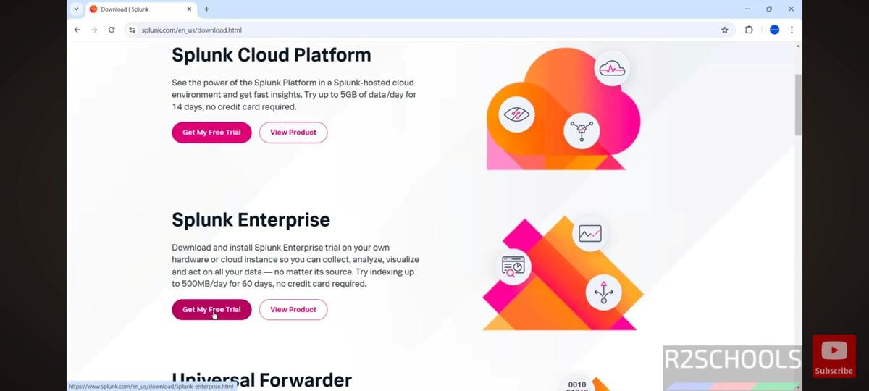
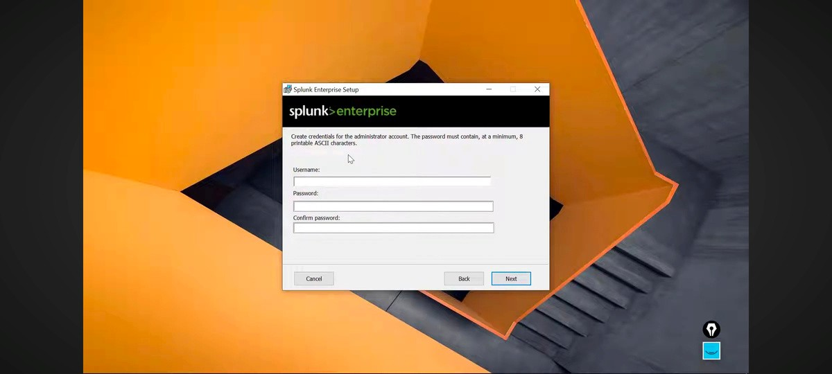

Id registeration

Id log in

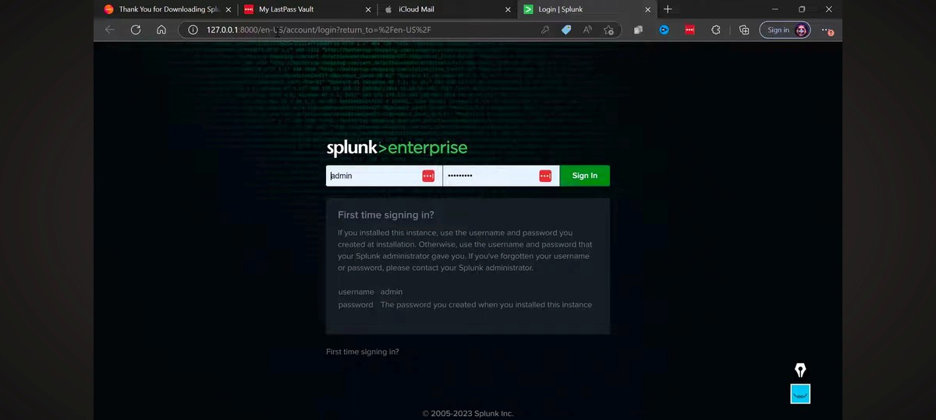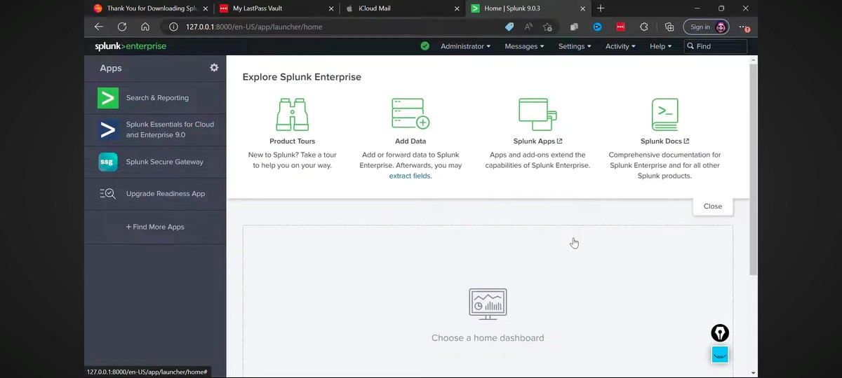

Search & regarding process

Home page
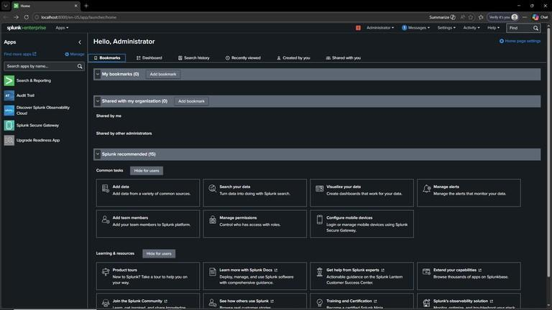

Practical No
Data Encryption Techniques

Data encryption techniques are methods used to protect data by converting it into an unreadable form called ciphertext. These techniques ensure that only authorized users can access the original information. Common encryption methods include symmetric encryption, where a single key is used for both encryption and decryption; asymmetric encryption, which uses a pair of public and private keys for secure communication; and hashing, which converts data into a fixed-length value that cannot be reversed. Modern systems often use a combination of these techniques to provide both security and efficiency in data protection.

Data Format – Text -> Hex -> Base64

– Step 1: Open CyberChef.io
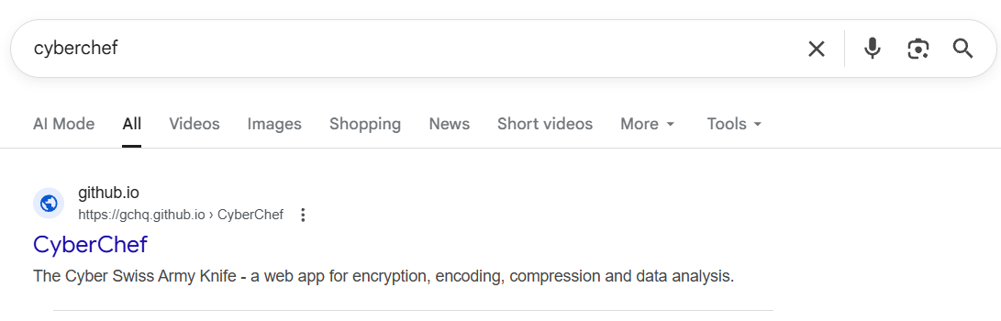

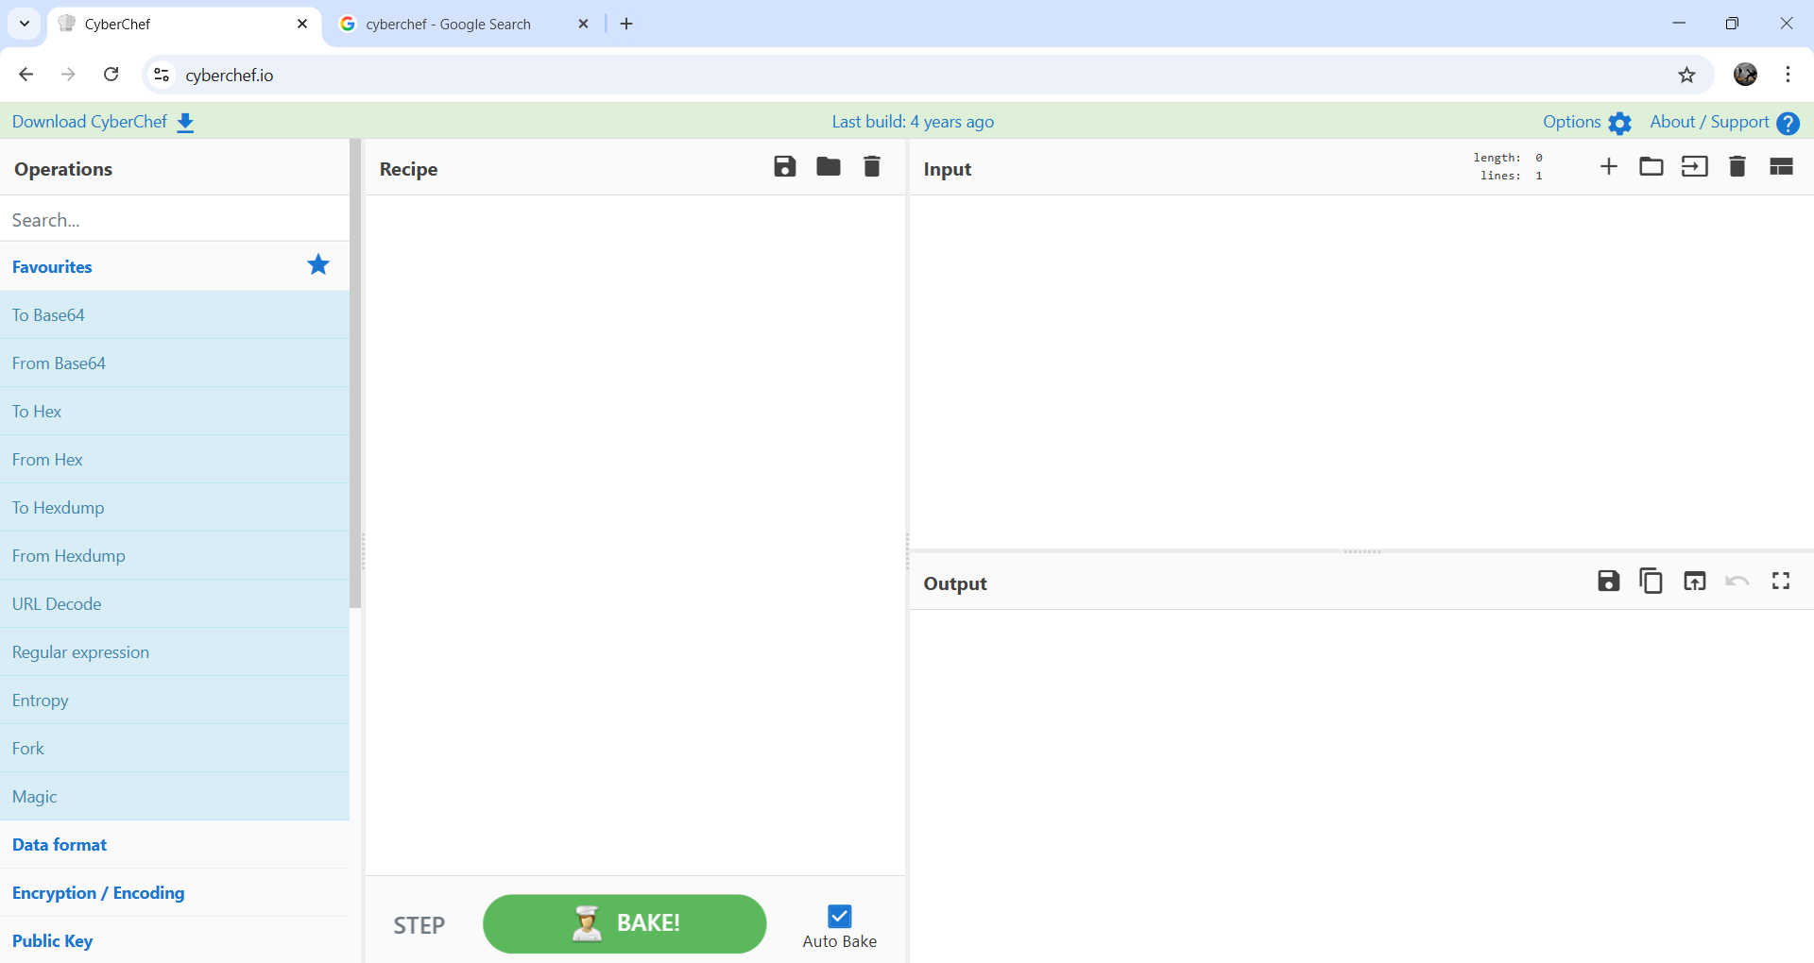
-- Step 2 – In the Input box, type = Hello

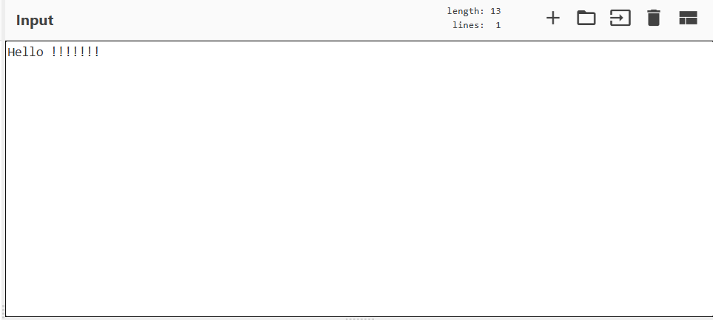

-- Step 3 – In the Operations (left panel) search and drag:
-To Hex then drag To Base64 below it.
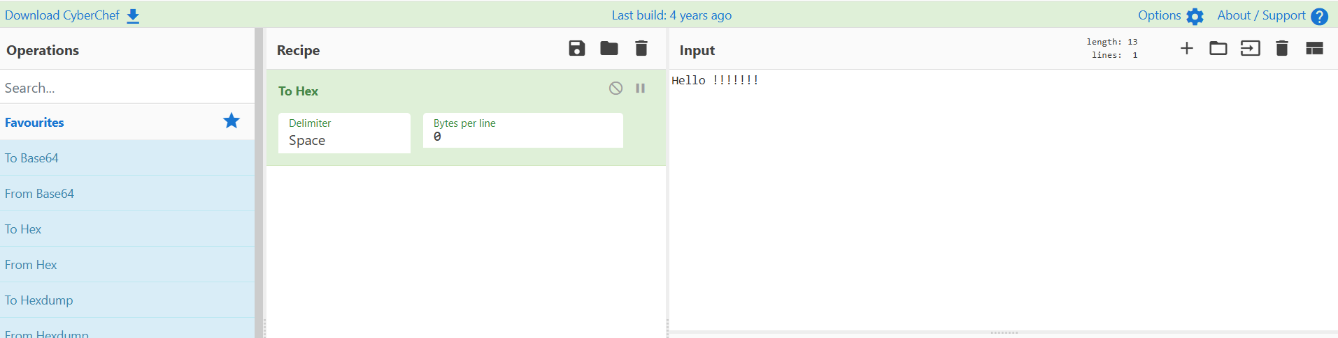

-- Step 4 – Click “Bake” and check Output :
- Output: SGVsbG8=

– It means that the "Hello" is converted to Hex and then encoded to Base64.
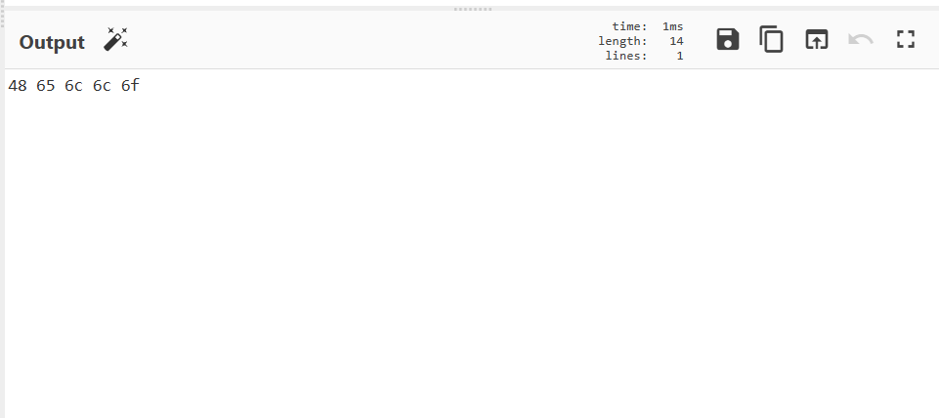

– Now select the From Hex and then drag and drop it to the recipe and then :
- Input: 48656c6c6f
- Recipe: Drag From Hex operation.
- Output: Hello

– The given Hex code 48656c6c6f is equal to text Hello.

– The output page will look like the screenshot given below.
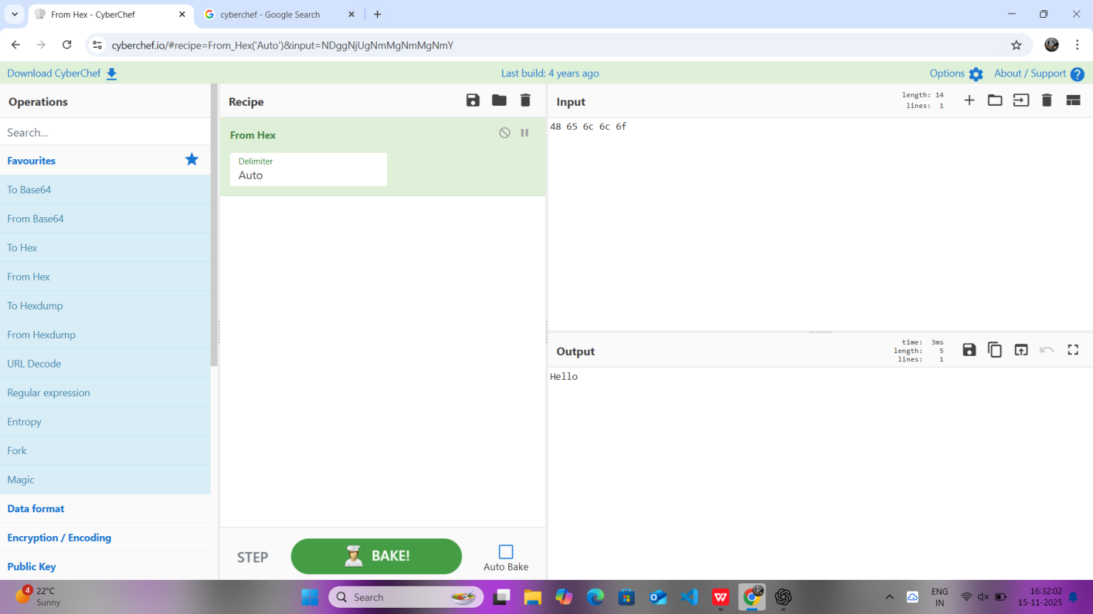

3.Binary – We will type hii in the input box .

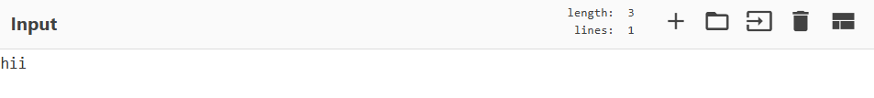

– Now select and drop binary from the left .

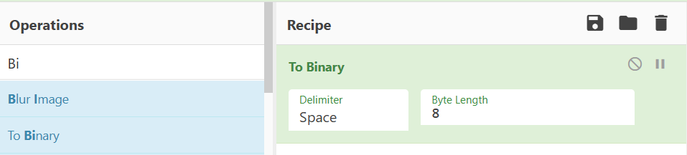

– Now click bake and the output will be a binary code .

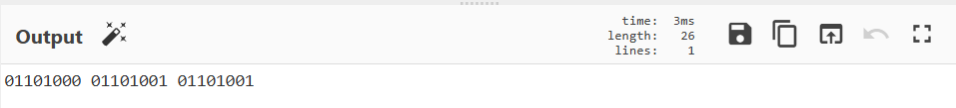

– Now select a binary code 01001000 01101001 and drag select From Binary , click bake.

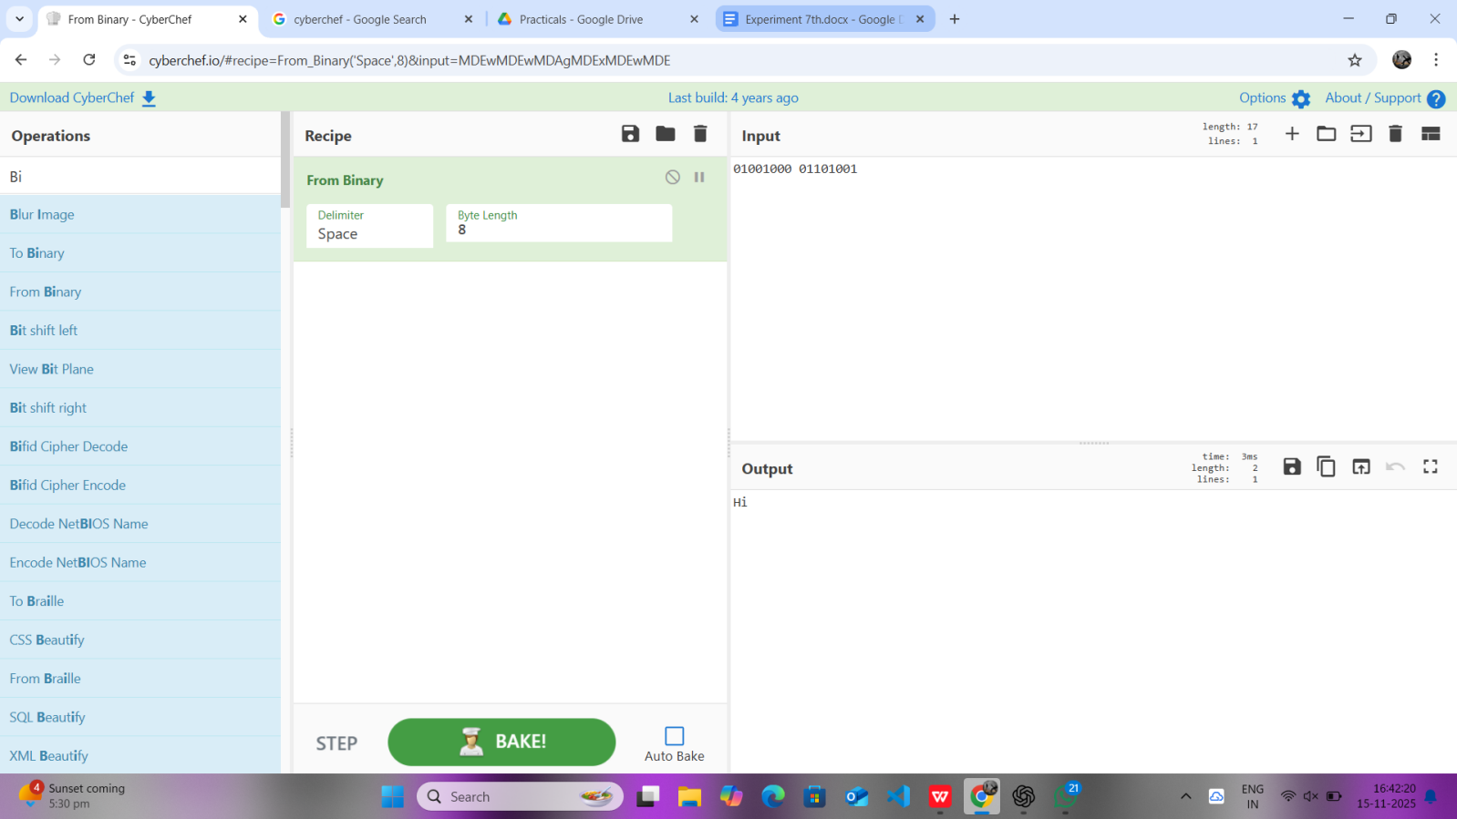

- Hexdump – We will type anythinng in the input box.

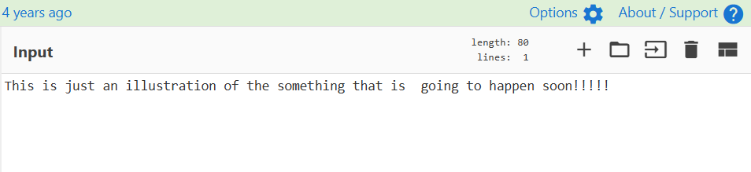
– Now select the To Hexdump option and drag and drop then click bake to see the output :

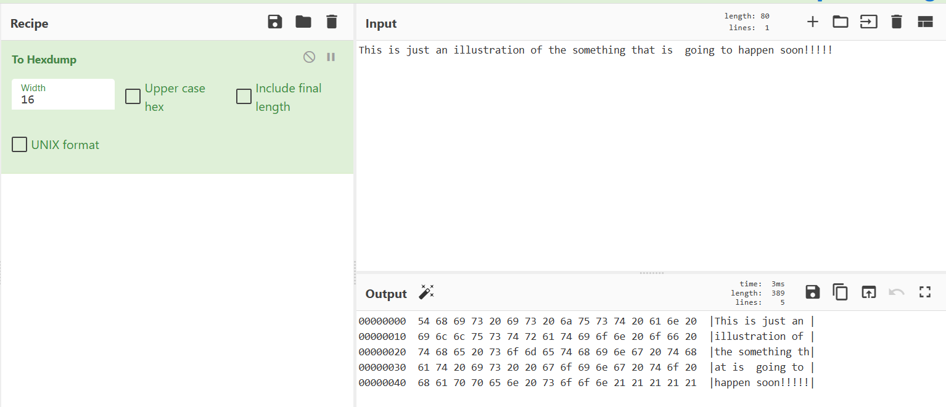
– Now clear everthing and then select From Hexdump and then again drop and drag then type 00000000 48 65 6c 6c 6f 20 57 6f 72 6c 64 0a in the input and click bake to see the Output: Hello World.

– It Converts hexdump data into readable text.

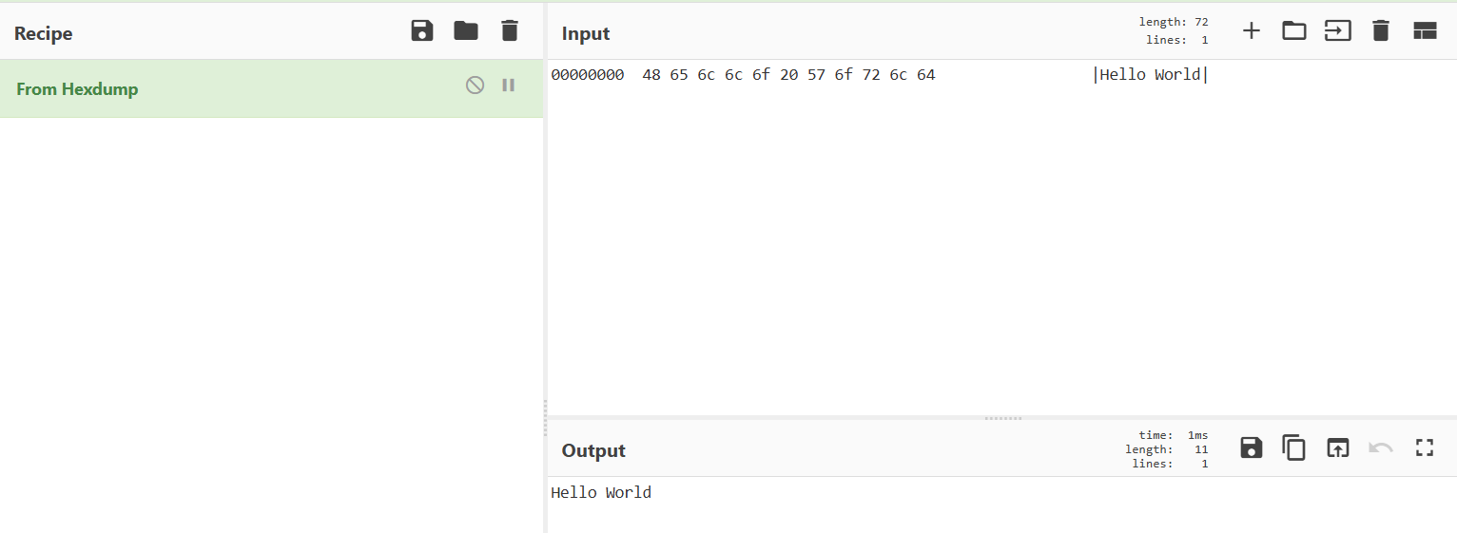

-- Encryption/Encoding – AES Encryption / Decryption

– Here we will do the encypting decrypting of the texts , means making it encrypted so that no one can read it , and then decrypt it so that we can read it .

– Our Input will be Hello CyberChef

– Now drag and drop the AES Encrypt and bake it .

– Additional information would be :

- Mode: CBC

- Key: 1234567890123456

- IV: 1234567890123456

- Input type: UTF-8
- Output : 5553d07e1f53561d61d07a8b25aef39d

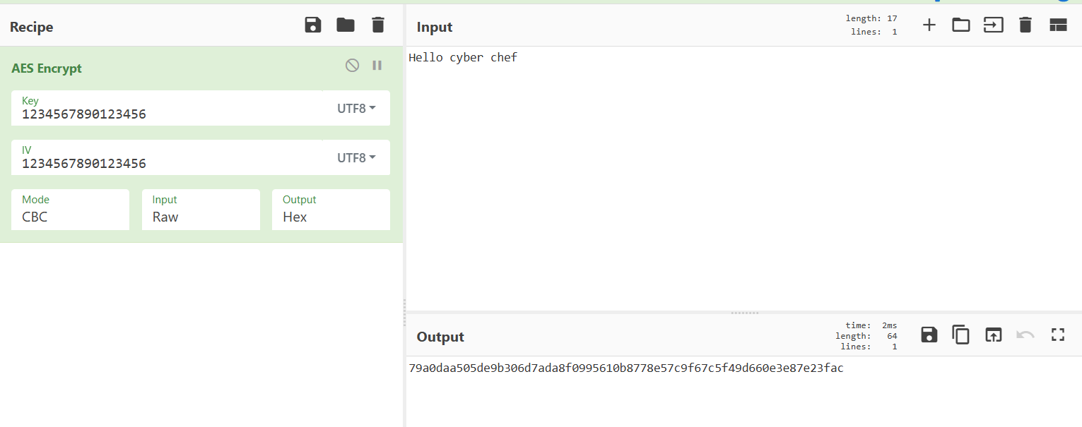

– Now we will Decrypt the same text :
- Input: 5553d07e1f53561d61d07a8b25aef39d
- AES Decrypt
- Mode: CBC
- Key: d0f5a37628af667ffc768c1d1a661374327121b08fa4043a2f9b2de7fe528c21
- IV: 1234567890123456
- Input type: UTF-8
- Output : Hello CyberChef

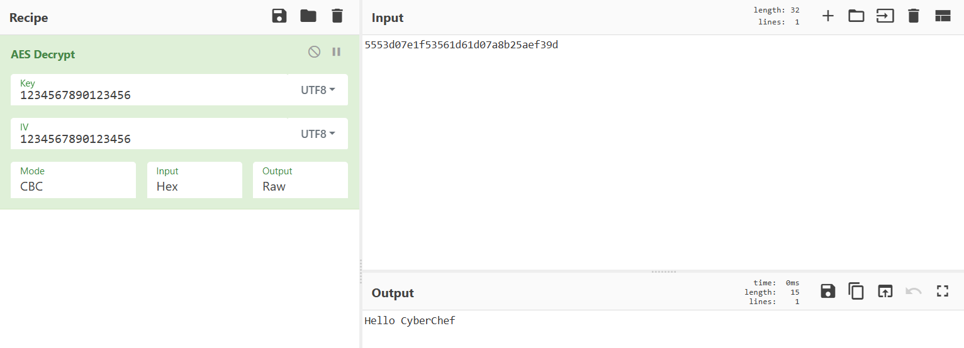

Practical No
Detection of Simulated Brute Force Attacks
&
Network Scanning and Attack Traffic Analysis

Aim
To simulate brute-force attack behavior by generating multiple failed login attempts on a Windows system, ingest the logs into Splunk, and create an alert for detection.

Objective
- To understand how brute-force attacks appear in logs
- To learn how to ingest log data into Splunk
- To analyze logs using SPL (Search Processing Language)
- To configure alerts for suspicious login activity

Tools Required
- Splunk Enterprise (Free Trial)
- Windows Operating System
- Notepad (for creating log file)

Project Structure
BruteForce-Detection-Splunk/
│
├── auth_simulation.log
├── screenshots/
│ ├── upload-log.png
│ ├── splunk-search-results.png
│ ├── alert-configuration.png
│ └── triggered-alert.png
└── README.md

Theory
A brute-force attack is a method used by attackers to gain unauthorized access by repeatedly trying different password combinations. These attacks generate multiple failed login attempts within a short period.
Security tools like Splunk can analyze such patterns in logs and trigger alerts when suspicious activity is detected.

Procedure
Step 1: Create a Log File with Simulated Login Attempts
- Open Notepad
- Create a log file with the following entries:
[2025-06-06 10:22:01] Failed login for user: admin from IP 192.168.0.5
[2025-06-06 10:22:02] Failed login for user: admin from IP 192.168.0.5
[2025-06-06 10:22:03] Failed login for user: admin from IP 192.168.0.5
[2025-06-06 10:22:04] Failed login for user: admin from IP 192.168.0.5
[2025-06-06 10:22:05] Failed login for user: admin from IP 192.168.0.5
[2025-06-06 10:22:06] Successful login for user: admin from IP 192.168.0.5
- Save the file as:
C:\logs\auth_simulation.log

Step 2: Ingest Log File into Splunk
- Open Splunk in browser:
http://localhost:8000
- Go to Settings → Add Data
- Upload the auth_simulation.log file
- Select Main Index
- Complete the upload process

Step 3: Run Search Query in Splunk
- Go to the Search & Reporting app
- Enter the following query:
index=* "Failed login"
| stats count by host, _time
| where count > 4
- This query identifies multiple failed login attempts occurring within a short time.

Step 4: Create an Alert in Splunk
- Click on Save As → Alert
- Configure the alert:
  - Alert Name: Windows Brute Force Simulation
  - Trigger Condition: When count > 4
  - Trigger Type: Real-time or Scheduled
- Set actions:
  - Log the alert
  - (Optional) Send email notification

Result
The simulated brute-force attack was successfully detected in Splunk.
An alert was generated when the number of failed login attempts exceeded the defined threshold.

Conclusion
This experiment demonstrated how brute-force attacks can be simulated and detected using Splunk. It helped in understanding log analysis, SPL queries, and alert configuration for identifying suspicious activities.

What I Learned
- Basics of Splunk setup on Windows
- Log simulation techniques
- Data ingestion in Splunk
- Writing SPL queries
- Configuring alerts for security monitoring

Future Scope
- Use real-time Windows Event Logs instead of static log files
- Integrate logs from PowerShell or Sysmon
- Create dashboards for better visualization
- Implement automated response actions
1)index="_internal"
define:- In Splunk, an index is a storage location for log data._internal is a special built-in index that stores logs about Splunk’s own operations.
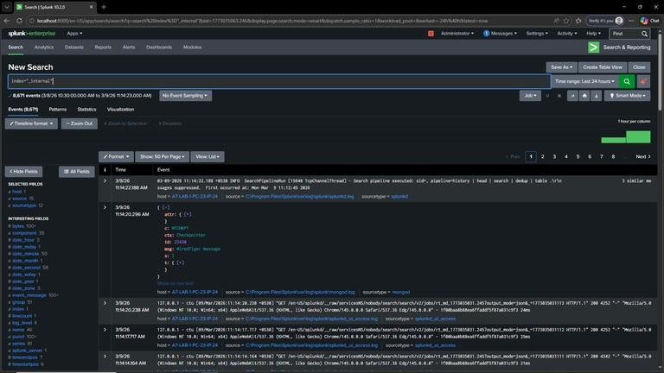

2)index="_internal" | table _time
Define:- This query searches events in Splunk’s internal logs and displays only the event timestamp (_time) in a table format.
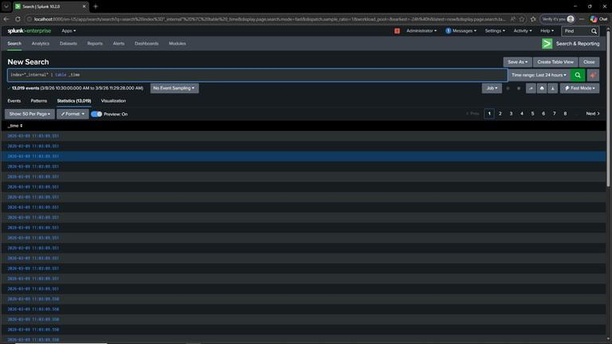

3) index="_internal" | table _time sourcetype source
Define:-This query retrieves events from the _{_internal} index and displays the fields _{_time}, sourcetype, and source in a table.
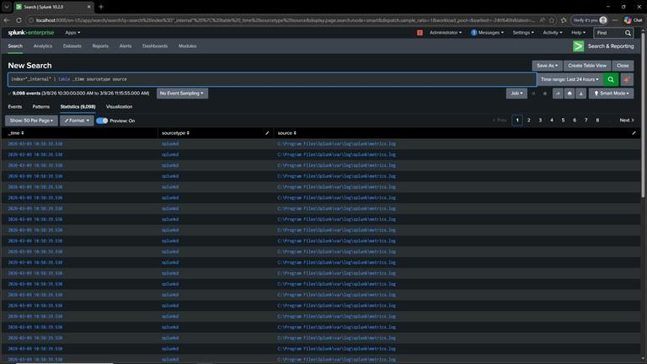

4) index="_internal" | stats count by _time source
Define:-This query searches the _internal index and calculates the number of events (count) for each combination of _time and source.
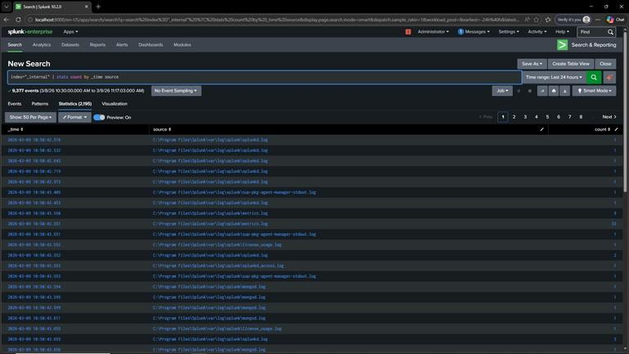
5) index="_internal" | stats count by _time sourcetype | rename count as "Count of Events"
Define:-This query searches the _internal index, counts the number of events for each _time and sourcetype, and renames the count field to "Count of Events".
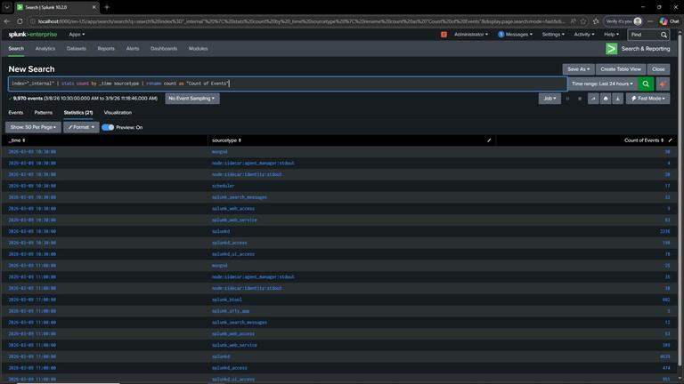
6)index="_internal" | stats count by _time sourcetype | rename name_label as host
Define:-This query searches the _{_internal} index, counts the number of events by _{_time} and sourcetype, and renames the field name_label to host.
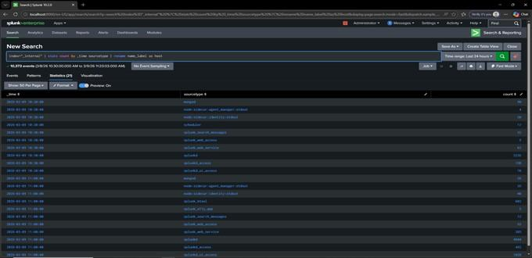
- index="_internal" | table _time sourcetype source date_hour | rename date_hour as hours
Define:-This query searches the _internal index, displays the fields _time, sourcetype, source, and date_hour in a table, and then renames the field date_hour to hours.
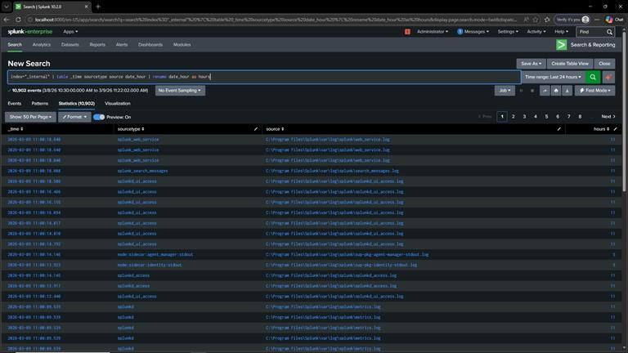
- index="_internal" | table _time sourcetype source date_hour | rename date_hour as hours | fields Definition:This query searches events from the internal Splunk index, displays selected fields (_time, sourcetype, source, date_hour) in a table, renames the field date_hour to hours, and uses the fields command to control which fields appear in the final search results.
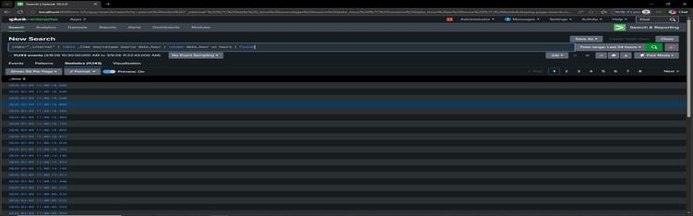
- index="_internal" | table _time sourcetype source date_hour | rename date_hour as hours | fields + host
Definition:-This query searches events from the internal Splunk index, displays _time, sourcetype, source, and date_hour in a table, renames date_hour to hours, and ensures the host field is included in the search results using the fields + command.
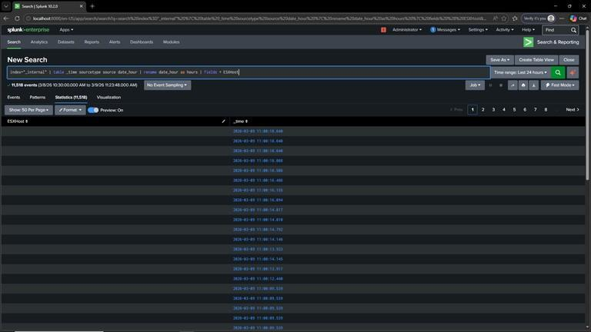
10)index="_internal" | table _time sourcetype source date_hour | rename date_hour as hours | fields + ESXHost
Definition:-This query searches events from the internal Splunk index, displays _time, sourcetype, source, and date_hour in a table, renames date_hour to hours, and ensures that the ESXHost field is also included in the search results using the fields + command. 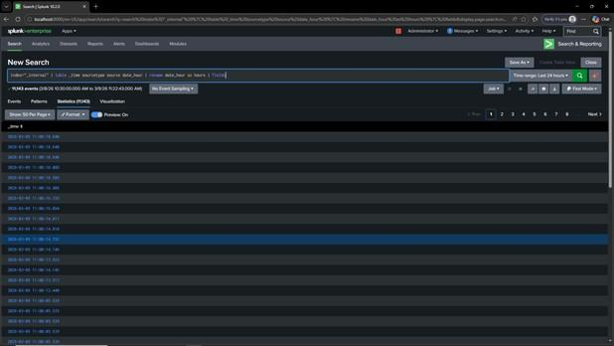

- index=_internal | stats count by sourcetype
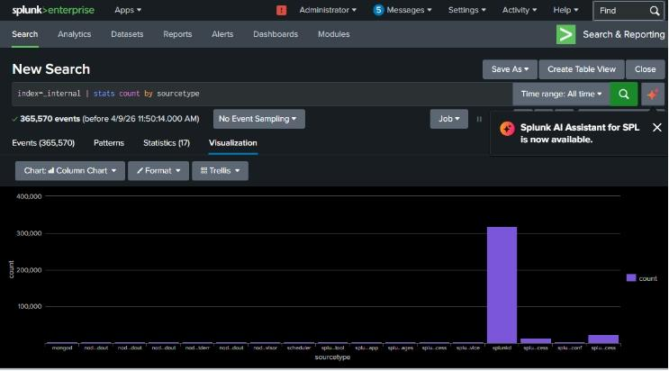

2)index=_internal | timechart count
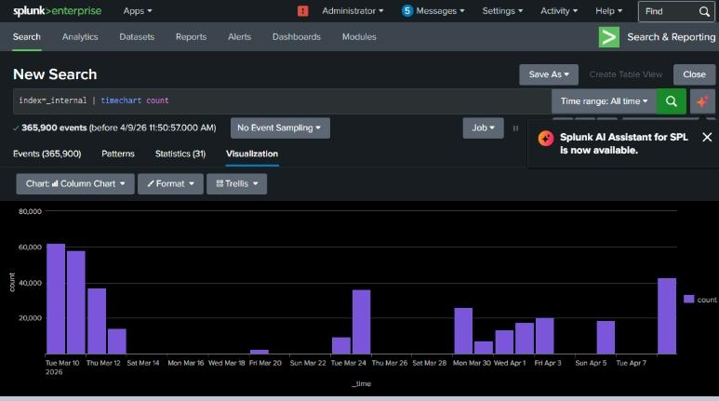

3)index=_internal | top host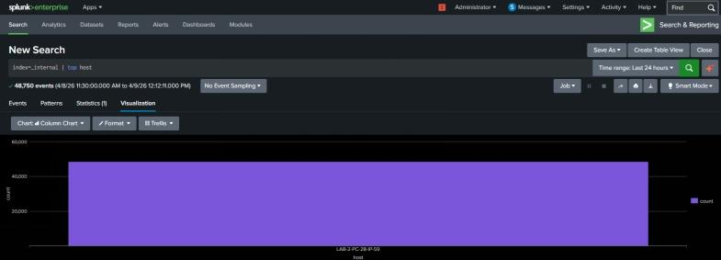 4)index=_internal | timechart count–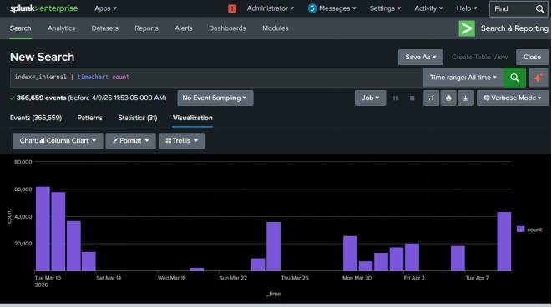

5)index=_internal | top limit=10 hos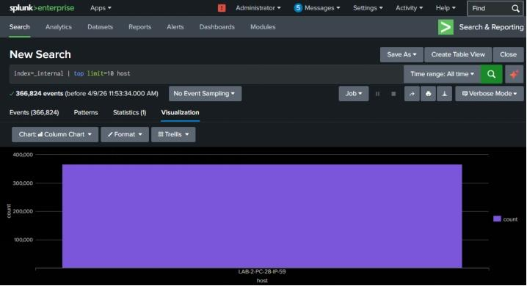 6)index=_internal | stats count by log_level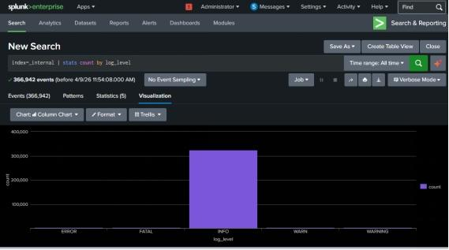

7)index=_internal | timechart span=1d count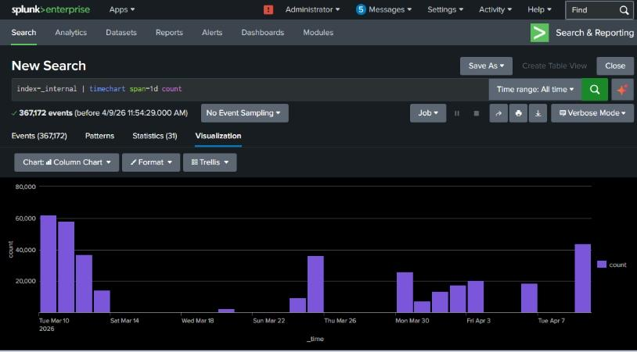 8)index=_internal | top source
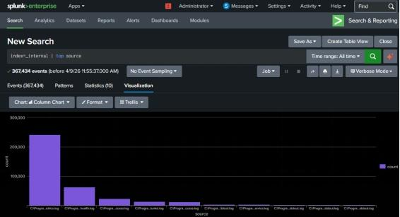
9) index=_internal | eval hour=strftime(_time,"%H") | stats count by hour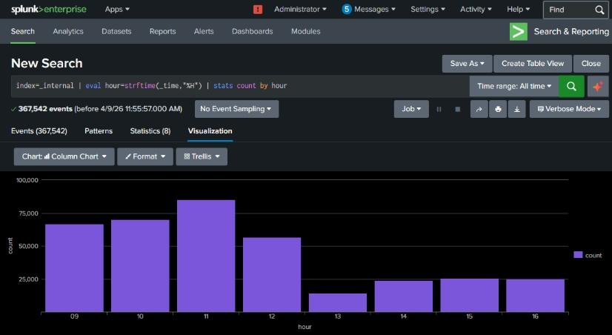 10) index=_internal | stats count by status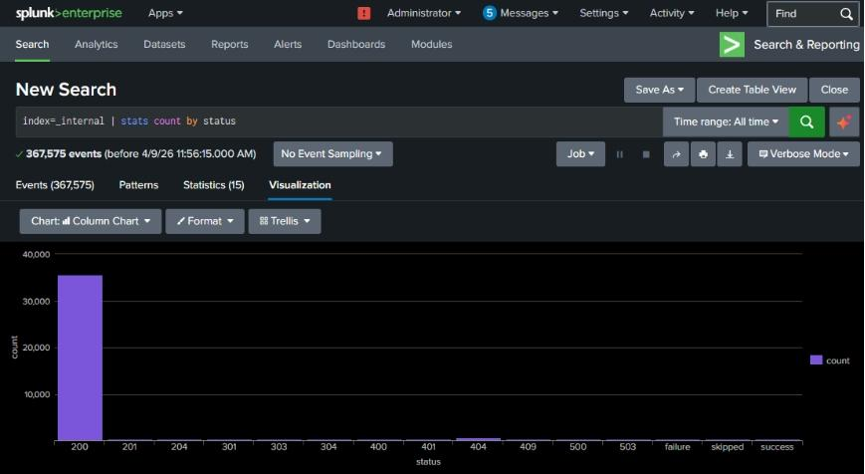
- index=_internal | timechart count by sourcetype limit=5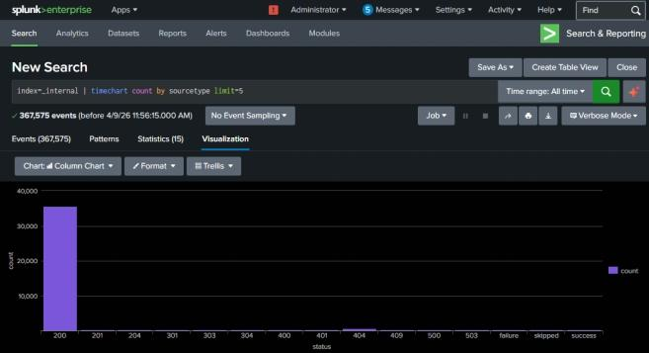
12) index=_internal | stats count by sourcetype | eventstats sum(count) as total | eval percent=(count/total)*100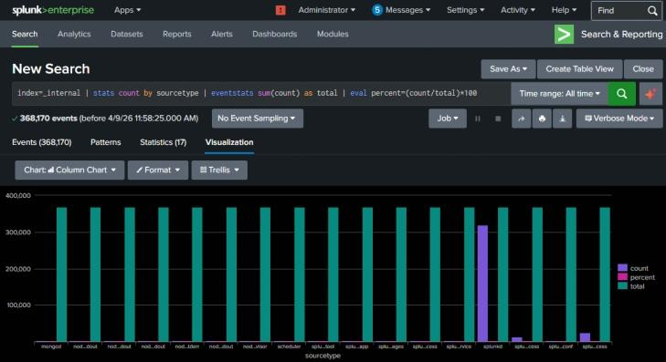
- index=_internal | stats count by source | sort –count
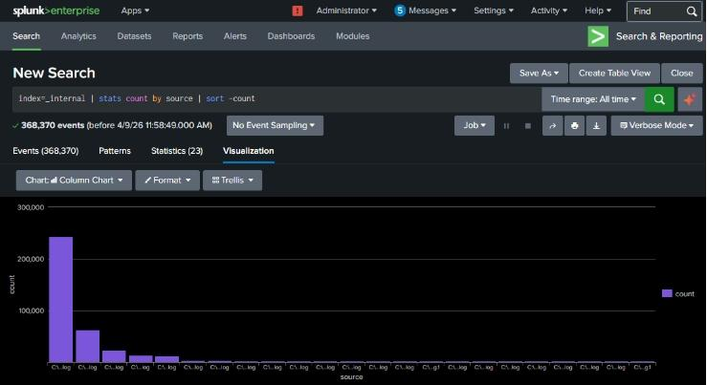

3)index=_internal | stats count by host | where count > 100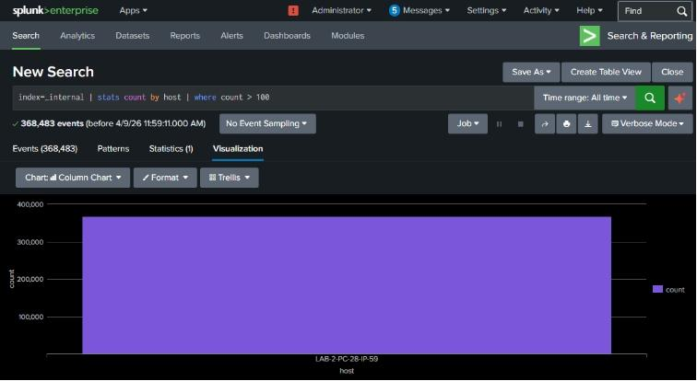

Practical No
Alert Creation and Security Dashboards
AIM:- Create real-time alerts for suspicious activities such as repeated login failures or malware indicators. Design dashboards displaying key security metrics, attack trends, and system health for continuous security monitoring.
Command for the Visualization in Splunk and Alert
1)index=_internal | stats count by sourcetype
2)index=_internal | timechart count
3)index=_internal | top host
4)index=_internal | timechart count
5)index=_internal | top limit=10 host
6)index=_internal | stats count by log_level
7)index=_internal | timechart span=1d count
8)index=_internal | top source
9) index=_internal | eval hour=strftime(_time,"%H") | stats count by hour
10) index=_internal | stats count by status
11) index=_internal | timechart count by sourcetype limit=5
12) index=_internal | stats count by sourcetype | eventstats sum(count) as total | eval percent=(count/total)*100
13) index=_internal | stats count by source | sort -count
14) index=_internal | stats count by host | where count > 100
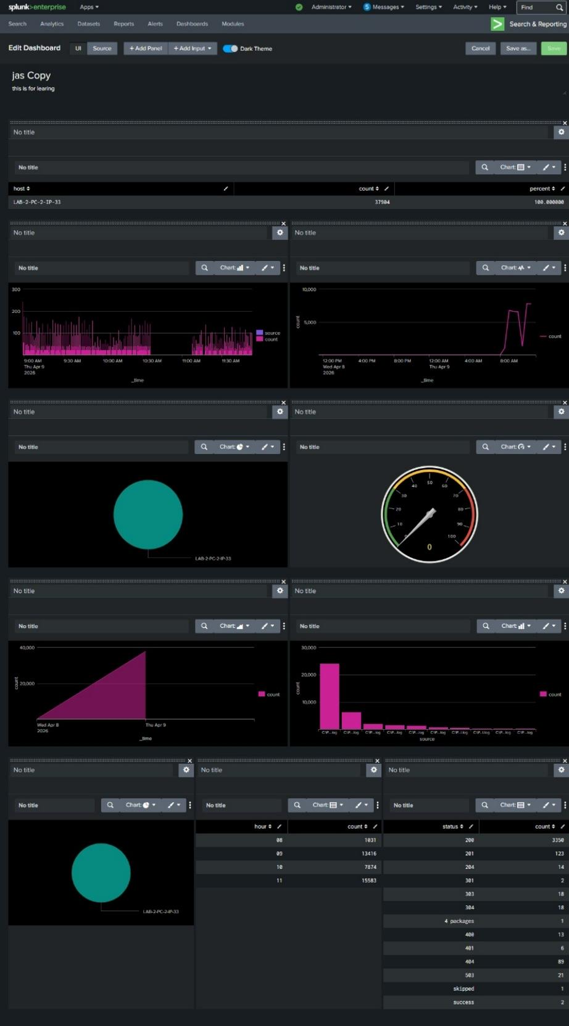Practical No.
Detection of Password In Plain Text Traffic
(Wireshark)

Wireshark is a GUI-based network protocol analyzer that captures live traffic and lets you inspect packets at every protocol layer. In this lab you will set up packet captures on an interface, apply capture and display filters (e.g., tcp, http, dns), follow TCP streams, and examine packet details such as headers, flags, and payloads. The exercise demonstrates how to identify conversations, troubleshoot connectivity issues, and spot anomalies like suspicious connections or malformed packets. Always capture traffic only on networks you own or have permission to monitor, because packet captures can contain sensitive data.

-- Step 1 (Open Wireshark) – Open terminal and type: sudo wireshark
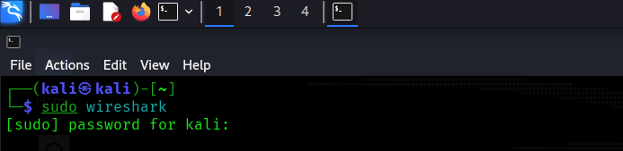
– Select your network interface (like eth0 or wlan0).
– Click Start Capturing.

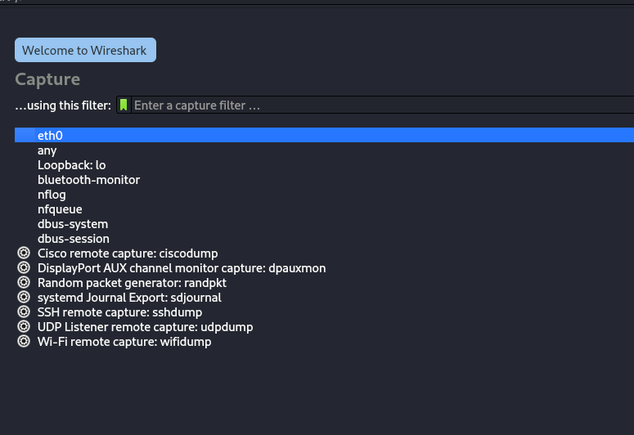

-- STEP 2 (Generate Traffic - Ping Test) – Open another terminal and type:
- ping 8.8.8.8

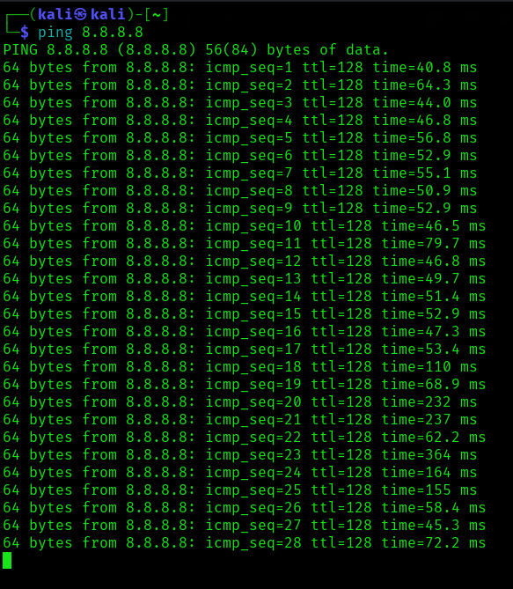

-- Internet Control Message Protocol – It is used by network devices to send error messages and operational information (like ping requests/replies).

– Example: when you ping 8.8.8.8, ICMP packets are sent and received.

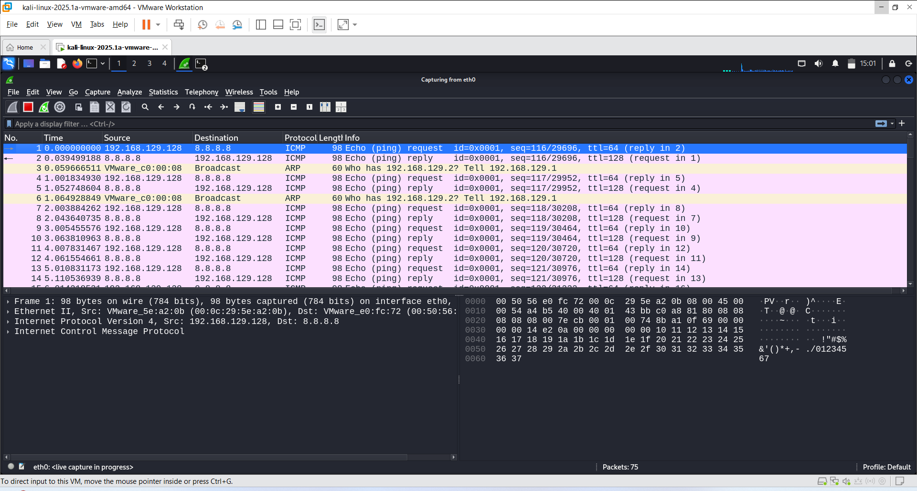
-- Step 3 (Display Filters - After Capture) – Use these filters in Wireshark’s Display Filter bar:

- ip.addr == 192.168.125.128 --> Show traffic for this IP.

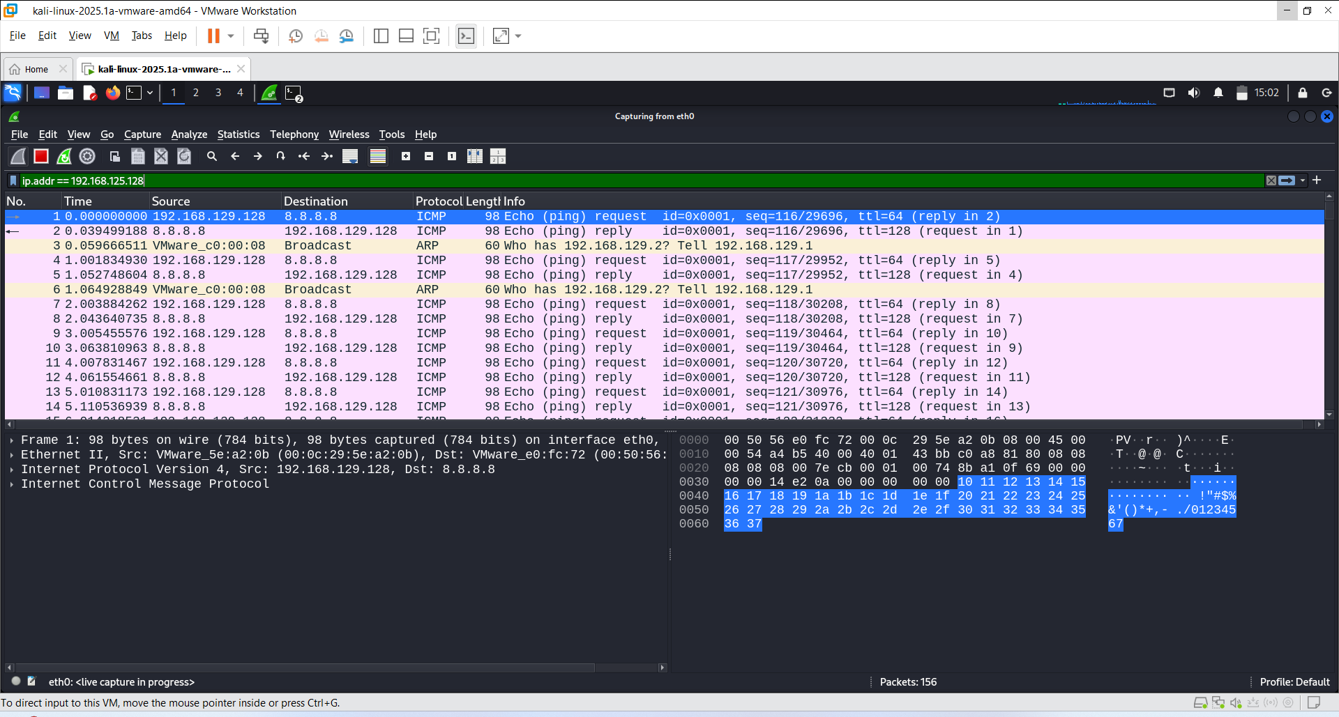
- ip.src == 151.101.65.91 --> Show packets from this IP.

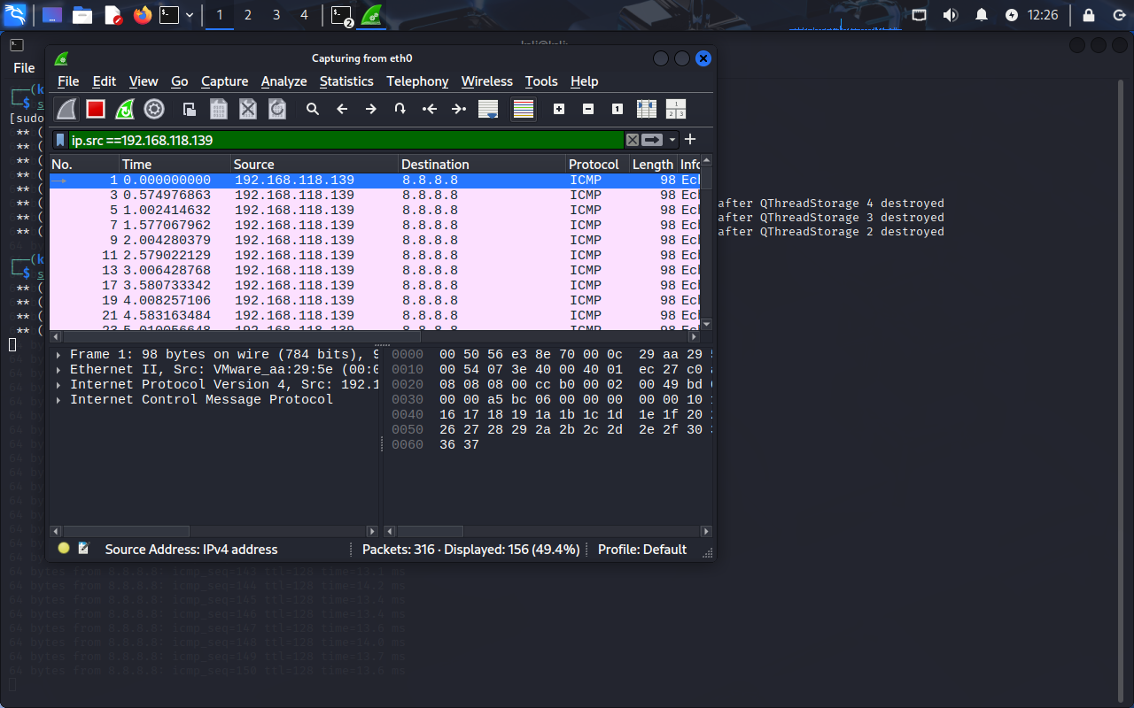

- tcp --> Show TCP packets.

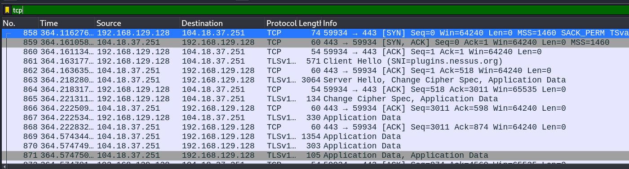
– If it was not showing tcp then we go the browser in kali linux any open any website that will identify its tcp and after that it start showing tcp of website.
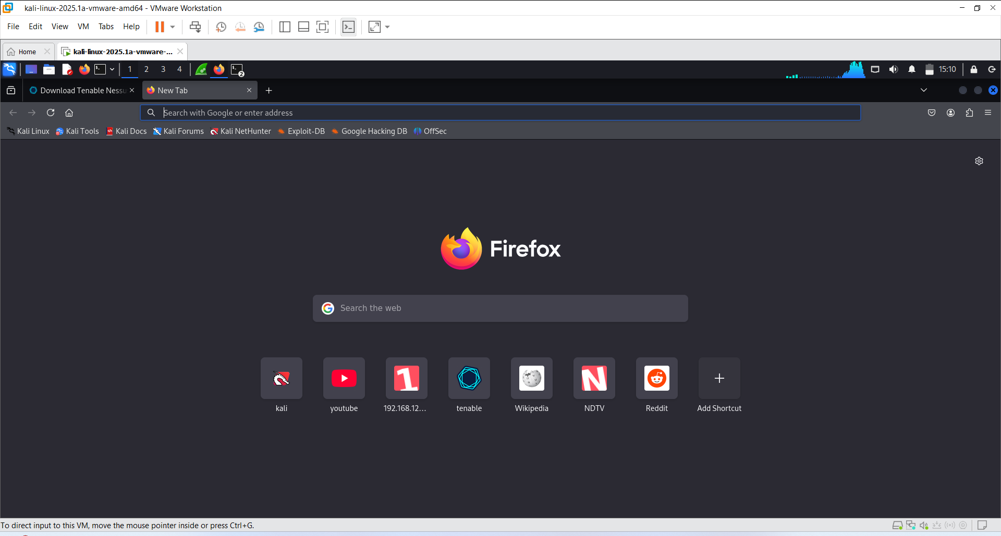
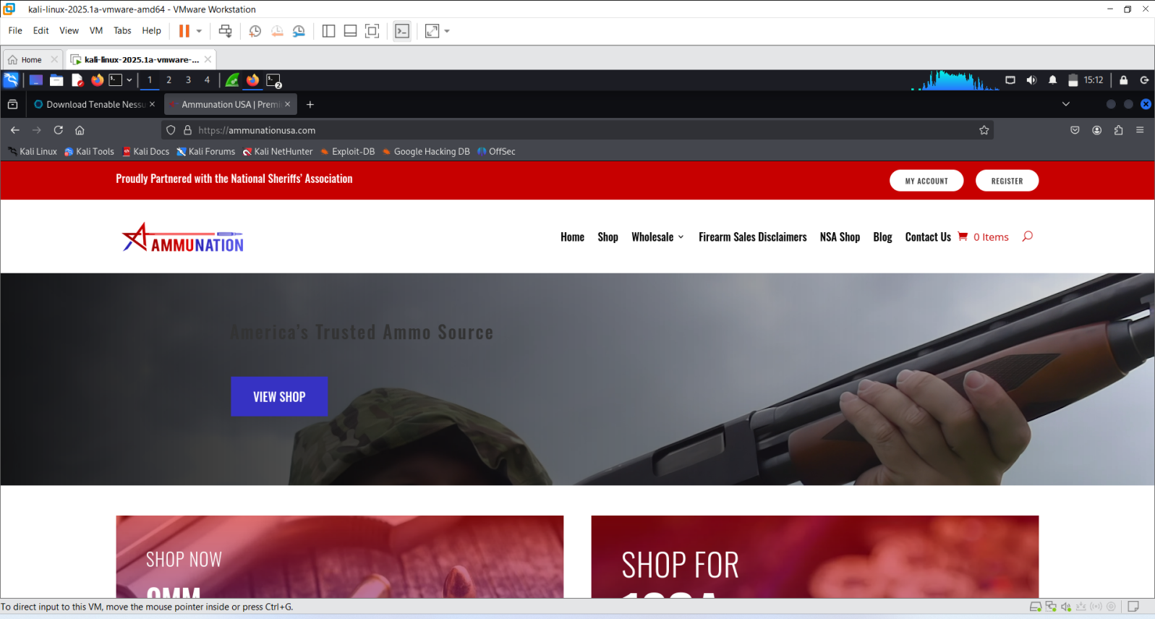

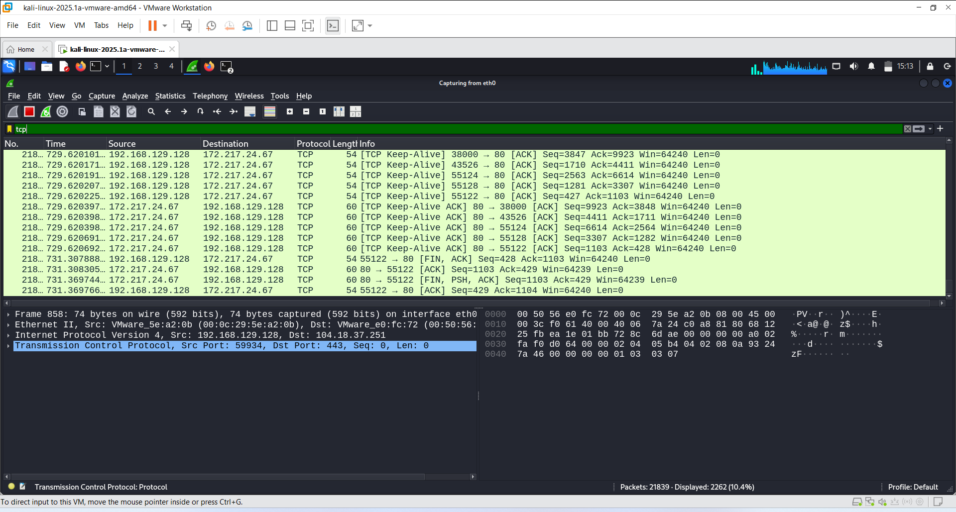

– http.response.code == 200 --> Show successful HTTP responses.

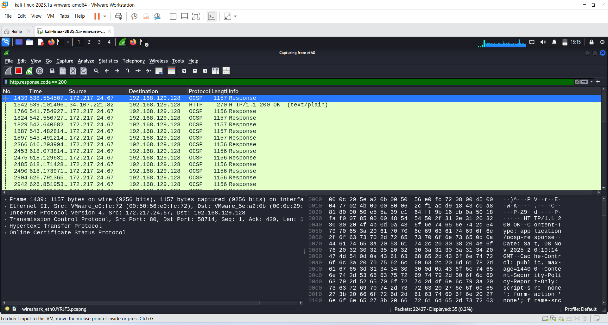

-- Step 4 (Capture Filters - Before Capture) – Capture filters tell Wireshark what packets to record while capturing.

– They filter traffic before it is saved, so unnecessary packets don’t fill your disk.

– How to Apply Capture Filters – Open Wireshark.

– Click on the interface you want to capture.

– In the Capture Filter box (next to Start), type your filter.

– Click Start to begin capturing only filtered traffic.

-- Common Capture Filters –
- By Host

Filter | Meaning
host 192.168.129.128 | Capture traffic to or from this IP
src host 192.168.129.128 | Capture traffic from this IP
dst host 192.168.129.128 | Capture traffic to this IP

-- 1 . host 192.168.129.128
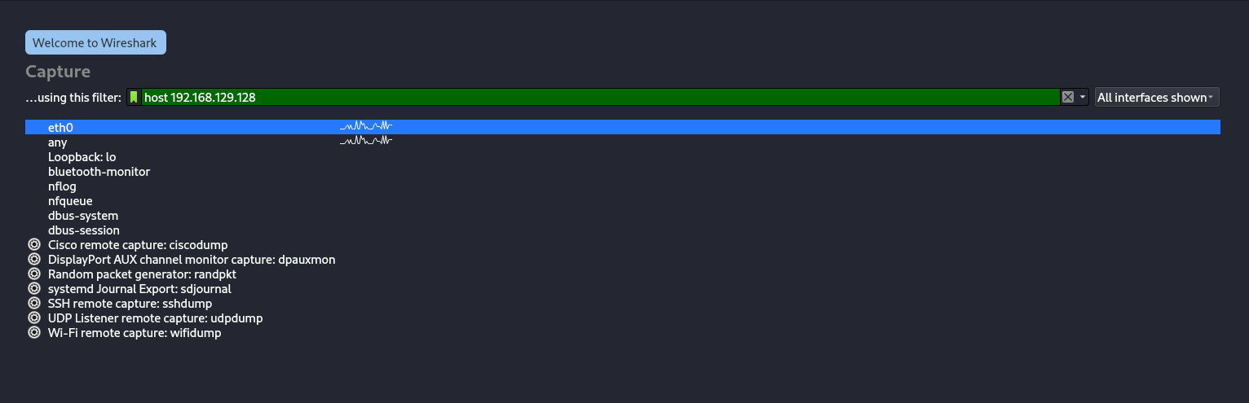

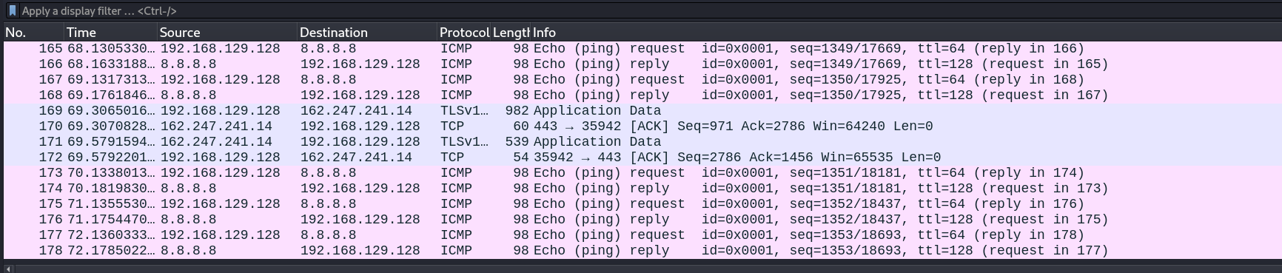

-- 2. src host 192.168.129.128
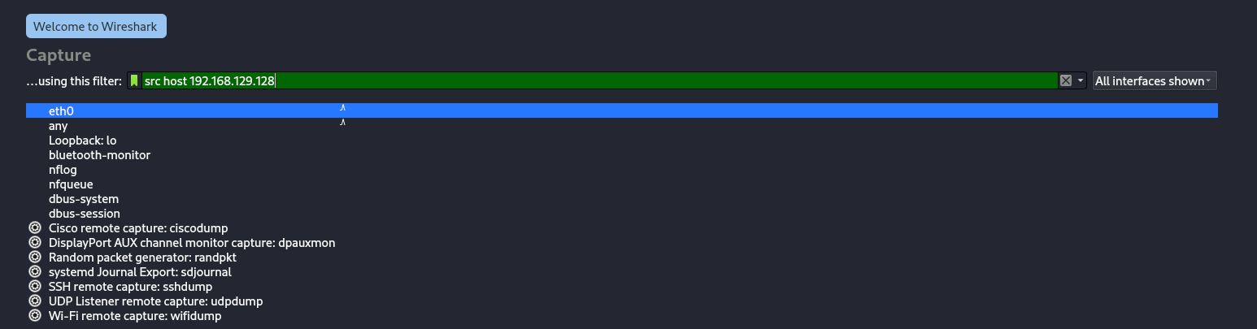
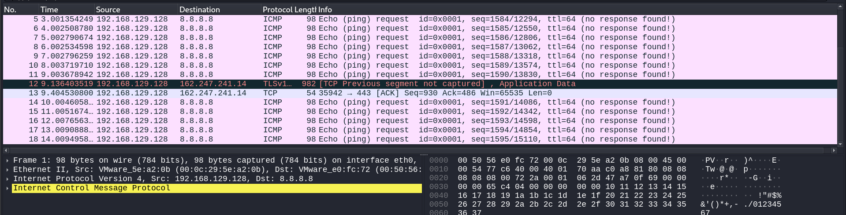

-- 3. dst host 192.168.129.128
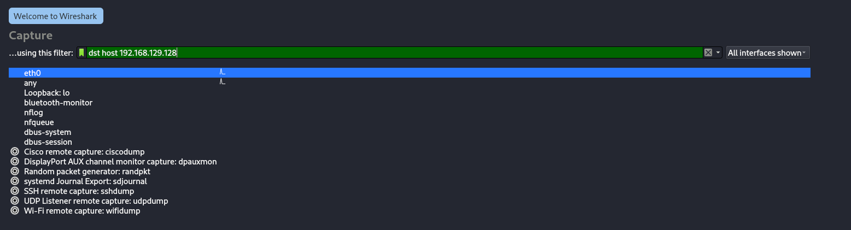

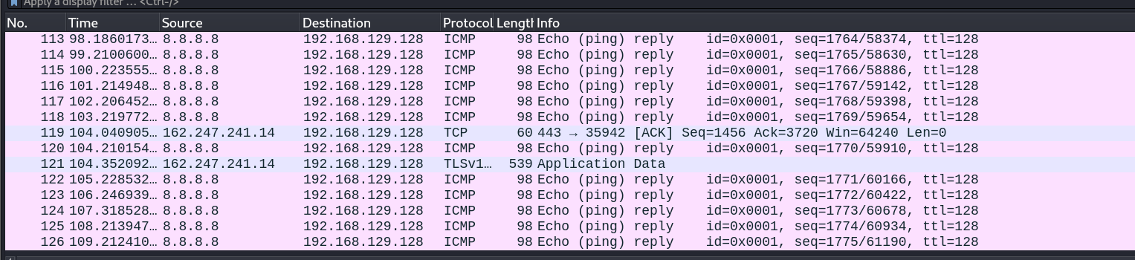

-- 2. By Network –
Filter | Meaning
net 192.168.129.128/24 | Capture all traffic in this subnet
src net 192.168.129.128/8 | Capture packets from this subnet
dst net 18.66.68.221/16 | Capture packets to this subnet

-- 1. net 192.168.129.128/24
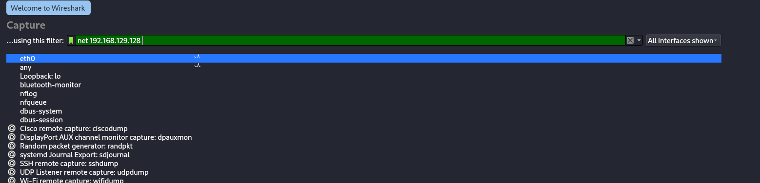
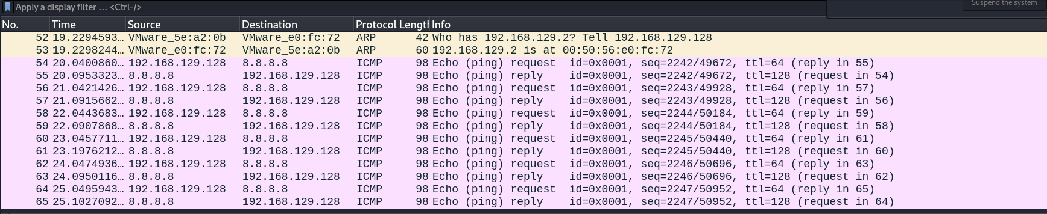

-- 2. src net 192.168.129.128

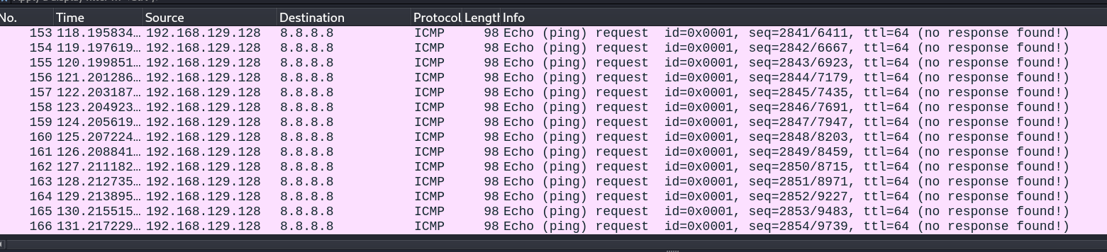

-- 3. dst net 18.66.68.221/16

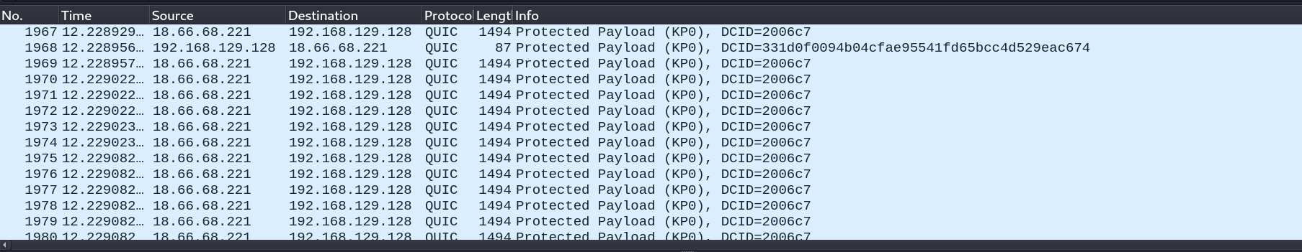

- By Protocol
Filter | Meaning
tcp | Only TCP packets
udp | Only UDP packets
icmp | Only ICMP packets (like ping)
arp | Only ARP packets

-- 1 . tcp


-- 2 . udp
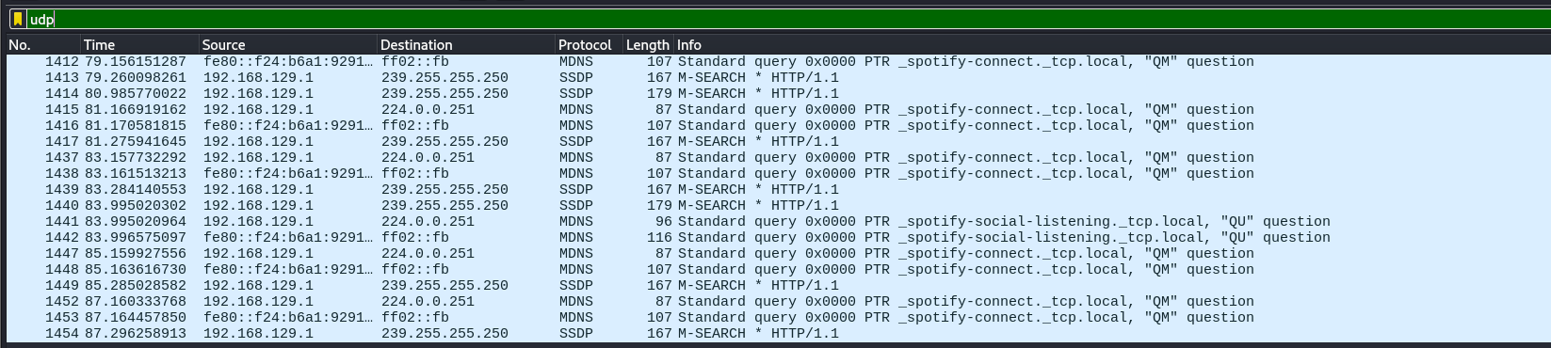
-- 3 . icmp
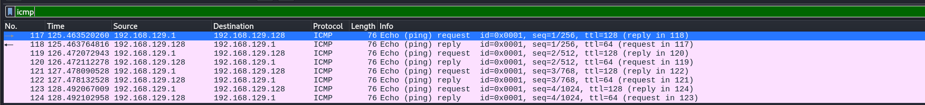

-- 4. arp
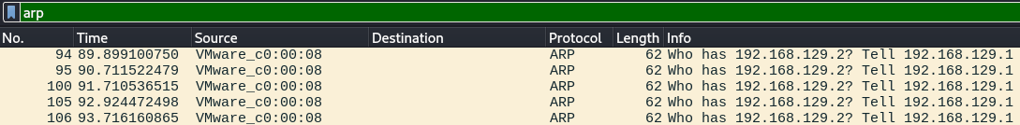
-- 4. By Port
Filter | Meaning
tcp port 80 | Only TCP traffic on port 80 (HTTP)
tcp port 443 | Only TCP traffic on port 443 (HTTPS)
udp port 53 | Only UDP traffic on port 53 (DNS)
portrange 1000-2000 | Capture traffic on ports 1000–2000

-- 1 . tcp port 80

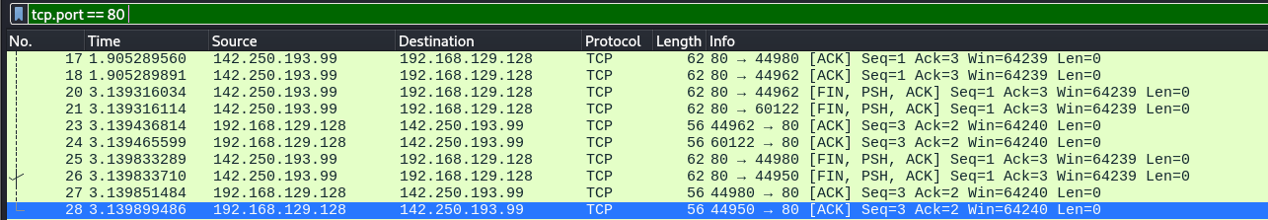

-- 2 . tcp port 443

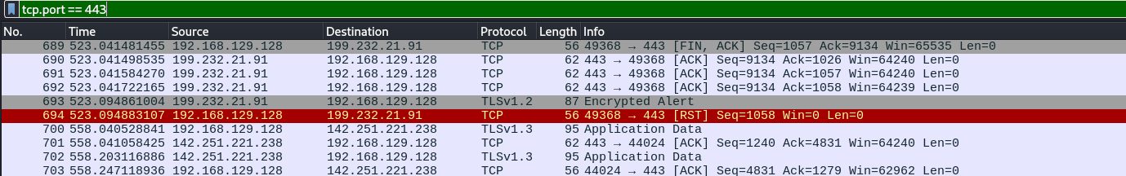

-- 3 .udp port 53

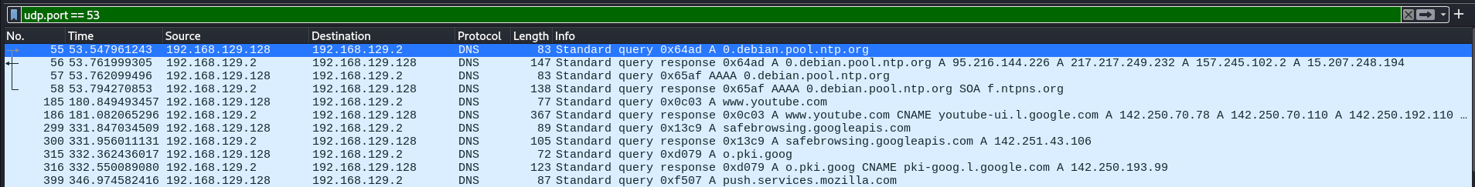

-- 5. Combine Filters – AND --> Both conditions must be true

– host 192.168.129.128 and tcp port 80

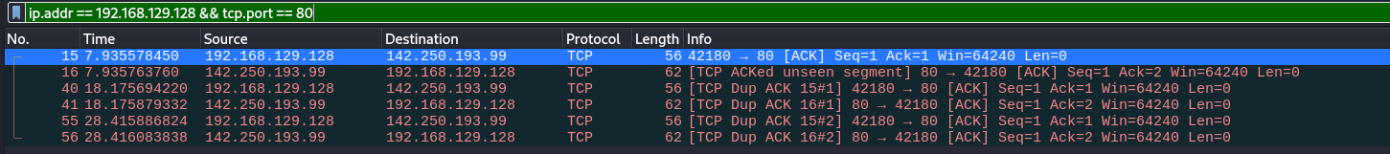

– OR → Either condition can be true:

- tcp port 80 or tcp port 443

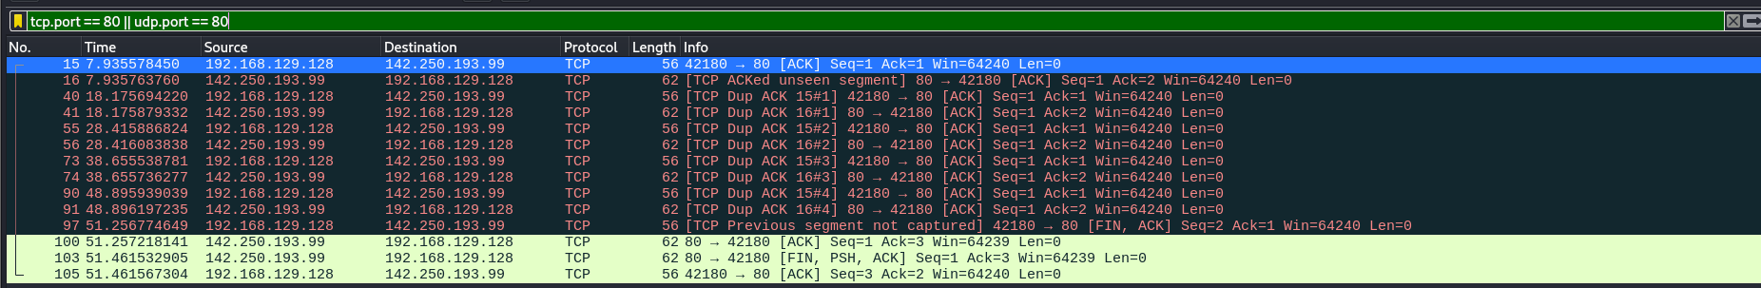

– NOT --> Exclude a condition not arp (Address Resolution Protocol)

